Investigation into Variations within Two-Person DNA Mixed Profiles.

Amanda J. Kirkham and James A. Lambert

Interpretation Research Group, 2003.

Contents Page

1. Introduction 3

2. Description of Data Sets 4

3. Data Analysis Results and Summaries
3.1 Behaviour of Mixing Proportion Estimate Formulae 5
3.2 Data Analysis 7
3.3 Spread in Mixing Proportion Estimators 18
3.4 Behaviour of Mixing Proportion Estimate Formulae – A Summary 21
3.5 Individual Mixing Proportion Estimate Formulae Effects 22 3.6 Locus Effects 25
3.7 DNA Concentration Effects 28

4. Review of +/- 35% Mixing Proportion Tolerance Window 30

5. Heterozygous Balance in Two-Person DNA Mixed Profiles 33

6. Performance Comparison of Applied Biosystems 377 and 3100 Instruments (with regard to two-person DNA mixed profiles) 35

7. Conclusion 36
8. Acknowledgements 37

9. References 37

10. Appendix A – Mixing proportion estimate formula 1 38

11. Appendix B – Mixing proportion estimate formula 2 42

12. Appendix C – Mixing proportion estimate formula 3 48

13. Appendix D – Mixing proportion estimate formula 4 54
14. Appendix E – Mixing proportion estimate formula 5 56

15 Appendix F – Spread in mixing proportion estimators 62

16. Appendix G – Individual Mx estimate formula effects 65

17. Appendix H – Individual locus effects 67

18. Appendix I – DNA concentration effects 68

Investigation into Variations within Two-Person DNA Mixed Profiles.

Amanda J. Kirkham and James A. Lambert, 2003.

1. Introduction

The scope of this report is a continuation and extension of preliminary analysis into the behaviour of mixing proportion estimate formulae (Triggs and Buckleton 2002, personal communications [1]) that form the basis of a DNA mixture interpretation software program ‘Pendulum’. It also includes a review of the +/- 35% tolerance window (contained within the mixture interpretation software), an evaluation of heterozygous balance within two-person DNA mixtures and a performance comparison of Applied Biosystems Automated 377 DNA Sequencer and 3100 Capillary Electrophoresis Instrument, with regard to two-person mixed DNA profiles.

The preliminary work into the behaviour of mixing proportion estimate formulae [1] has been further extended in this report by analysing an additional 75 two-person mixed DNA profiles (69 two-person mixed DNA profiles were examined in the initial study). The study investigated the effects and interactions of each individual formula, locus and DNA template concentration. The aim was to establish which mixing proportion formulae, in terms of allele combinations, are the most reliable when used to estimate the mixing proportion. The observed results offer important information and knowledge regarding the behaviour of two-person DNA mixtures. This information is essential in providing confidence in the formulae, as these provide the basis of a DNA mixture interpretation software program ‘Pendulum’ and will also be vital for mixture simulation modelling research.

In order to take into account any PCR variation and/or preferential degradation of the mixed DNA profile, a +/- 35% tolerance window has been included within the mixture interpretation software, M. Bill and I. Rattle [2]. This is to compensate for any variances of mixing proportion, per locus, within a single mixed profile. A review of these test data sets has been carried out, with variations of mixing proportion estimates recorded. This analysis will then check whether or not the +/- 35% tolerance window used in the software is justified.

The data sets were also investigated with regard to heterozygous balance. All four-allele locus peak area information was recorded and analysed, in order to define how evenly and balanced these loci amplified within each PCR. This evaluation was interested in discovering whether or not there was any evidence of allelic behavioural differences and effects caused by the DNA being a mixed rather than a single profile.

The performance comparison between the Applied Biosystems “Automated 377 DNA Sequencer” and “3100 Capillary Electrophoresis Instrument”, was facilitated by the acquisition of the data set which originated from the validation study of the 3100 instrument, K. Tsang [3]. A performance comparison and validation study was necessary, as the 3100 instrumentation is vital to the automation of DNA analysis. The study had to prove whether or not results from the 3100 instrumentation are equally as good as those from the 377 instrumentation (currently used in the FSS). Both sets of two-person DNA mixed profile data from the 377 and 3100 equipment were analysed separately, in order to fulfill this report’s analysis requirements into the mixing proportion formulae and also to enable a direct comparison of results from both sets of equipment. This study will serve as a direct performance comparison and also demonstrate how reliable the data derived from both equipment platforms is with regard to two-person mixed DNA profiles.

2. Description of Data Sets

Two different data sets were analysed in this study. They originated from two-person mixtures artificially created in the laboratory and used in two separate and different studies.

Study one was originally designed and used for the validation of the Applied Biosystems 3100 instrument for casework applications [3]. Samples were created using good quality template DNA, obtained from two individuals using standard operating procedures. After the DNA was extracted, it was quantified and mixed in proportions using concentrations of 1ng of DNA, in order to create mixture ratios of: 10:1; 5:1; 1:1; 1:5; 1:10, with each being repeated in triplicate, giving a total of 15 two-person mixed DNA profiles. The ratios were chosen to give a broad range of DNA mixture combinations, in order to test the sensitivity of the system undergoing validation.
All samples were amplified using the AMPF1STR® SGM Plus ™ multiplex kit (Applied Biosystems). A standard operating procedure was followed as stated in Cotton et al. 2000 [5]. Each individual mixture ratio created was sampled twice, one sample run on an automated DNA sequencer (model 377 Applied Biosystems) – creating 377 data set results; and the other sample run on the 3100 equipment, creating 3100 data set results, giving a true comparison of the different electrophoretic platforms. The data were analysed using Genescan™ software (Applied Biosystems), as described in [5]. All peak areas were derived from the software program and were not subjected to any editing or cleaning processes.

Study two was originally created to test and validate a software package designed to interpret DNA mixtures (A. Lowe created the mixed DNA profiles [2]). In order to validate the software, mixed profiles were created to test the software as comprehensively as possible, with many different allelic combinations. In this study both ratio and DNA concentration were varied, with ten combinations of seven individuals were used to create the two-person mixed DNA profiles studied here. For each two-person combination, six profiles were constructed with the following DNA concentrations: 2.0ng, 1.5ng, 1.0ng and 0.5ng. The 0.5ng DNA concentration profiles were created in triplicate in order to compensate for any sampling differences during experimental set up. The ten combinations were paired and each pair constructed into one of the following ratios: 10:1, 5:1, 3:1, 2:1, and 1:1 (thus each ratio was duplicated).

Amplification of samples were done using the above-mentioned AMPF1STR® SGM Plus ™ multiplex kit (Applied Biosystems). All mixtures were run on an automated 377 DNA sequencer (Applied Biosystems), analysis carried out using Genescan™ software (Applied Biosystems). As before, all peak areas were derived from the software program and not subjected to any editing or cleaning processes. These created the QLB (377) data set results (QLB is a gel identifier reference only and does not signify anything else).

NB. No adjustments have been made to the raw allelic peak area information to allow for the presence or absence of artefacts (e.g. stutter and n banding) that could share these positions. All allelic peak areas information has been derived directly from the software.

3. Data Analysis and Results

3.1 Behaviour of Mixing Proportion 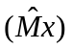Estimate Formulae

The mixing proportion estimate formulae analysed here have been used as the basis of the ‘Pendulum’ software program designed to interpret two-person mixed DNA profiles and is based on the theory presented in [4]. The program uses peak area information combined with the Mx estimate formulae, in order to determine the probable mixing proportion (Mx) for allelic pairs and thus the major/minor genotype combinations (thus no ratios are used within the program, only mixing proportions). The software also assumes a linear relationship between peak area and DNA template level that is as the DNA template amount increases, so the peak areas increase also.

Mixing Proportion Estimate Formulae

The following is a list of mixing proportion estimate formulae under test:

3.1.1 Mx Estimate Formula 1 - Four allelic peak loci, consisting of two non-overlapping heterozygotes.
Here there are four distinct allelic peaks that are designated as A1, A2, A3 and A4 (where peaks A1 and A2 come from known contributor one and peaks A3 and A4 from known contributor two).

Estimated mixing proportionis calculated by using the formula:

Contributor 1 Contributor 2
A1, A2 A3, A4 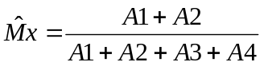

3.1.2 Mx Estimate Formula 2 - Three allelic peak loci, consisting of non-overlapping heterozygote and homozygote.
The three allelic peaks are designated as A1, A2 and A3 (where peak A1 comes from the homozygote contributor and peaks A2 and A3 come from the heterozygote contributor).

Estimated mixing proportionis calculated by using the formula:

Contributor 1 Contributor 2
A1, A1 A2, A3 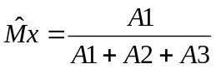

Contributor 1 Contributor 2
A2, A3 A1, A1 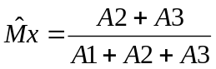
3.1.3 Mx Estimate Formula 3 - Three allelic peak loci, consisting of two heterozygotes sharing one allele.
The three allelic peaks are designated as A1, A2 and A3 (where peak A1 identifies the allele shared by both contributors).

Estimated mixing proportionis calculated by using the formula:

Contributor 1 Contributor 2
A1, A2 A1, A3 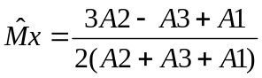

3.1.4 Mx Estimate Formula 4 - Two allelic peak loci, consisting of two non-overlapping homozygotes.
At these loci there are two homozygous alleles, with no alleles being shared. The allelic peaks are designated as A1 from contributor one and A2 from contributor two.

Estimated mixing proportionis calculated by using the formula:

Contributor 1 Contributor 2
A1, A1 A2, A2 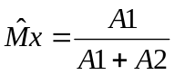

3.1.5 Mx Estimate Formula 5 - Two allelic peak loci, consisting of one heterozygote and one homozygote sharing one allele.
The areas of the allelic peaks have been designated as A1 and A2.

When A2 is the shared allele, the estimated mixing proportionis calculated by using the formula:

Contributor 1 Contributor 2
A1, A2 A2, A2 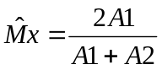

When A1 is the shared allele, the estimated mixing proportionis calculated by using the formula:

Contributor 1 Contributor 2
A1, A1 A1, A2 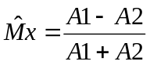

3.2 Data Analysis

For each mixture the mixing proportion was estimated at every locus using the relevant formulae, as described in the results. Data were also reversed at each ratio (except ratio of 1:1) in order to remove any preferential choice of contributor. The mixing proportion estimates were calculated using the relevant mixing proportion estimators as defined by the structure of the locus under question.

3.2.1 Mixing Proportion Estimate Formula 1 – Four Allelic Peak Loci, Two Non-Overlapping Heterozygotes.

In the 377 and 3100 data sets, three loci (D16, D2 and D19) consisted of two non-overlapping heterozygotes, giving four distinct allelic peaks. The QLB (377) data set had various loci throughout the ten profiles, consisting of two non-overlapping heterozygotes. The areas of the four peaks were designated as A1, A2, A3 and A4 (where A1 and A2 come from known contributor one and A3 and A4 from known contributor two).

The following estimate was used for this four peak loci, in order to calculate the estimated mixing proportion (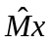):

Contributor 1 Contributor 2
A1, A2 A3, A4

Where there are four distinct allelic peaks at loci within a two-person mixture, it allows the unequivocal identification and thus measurement of the allelic peak areas. Here, the mixing proportion is best determined and therefore the mixing proportion estimate is more accurate and reliable.

3.2.1.1 Data Set One - 377 and 3100 Instrument Data.

The mixing proportions were calculated for each 4 allelic peak loci, using the correct Mx estimate formula (1). The resulting Mx values were plotted on box and whisker plots in order to visualise the data distribution, using MINITAB Statistical Software package, version 12.

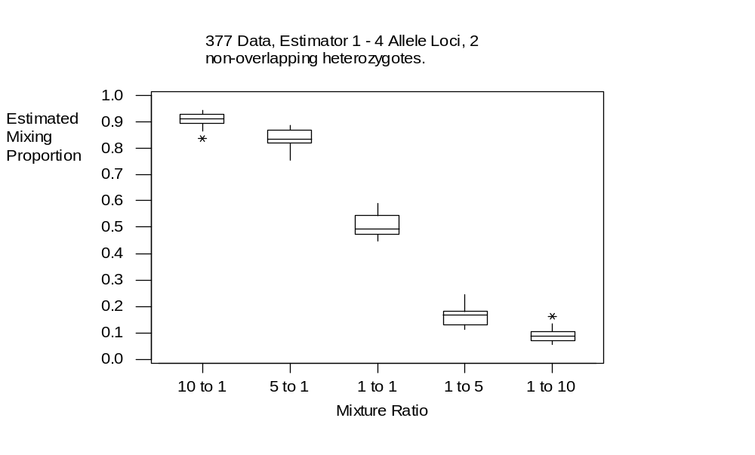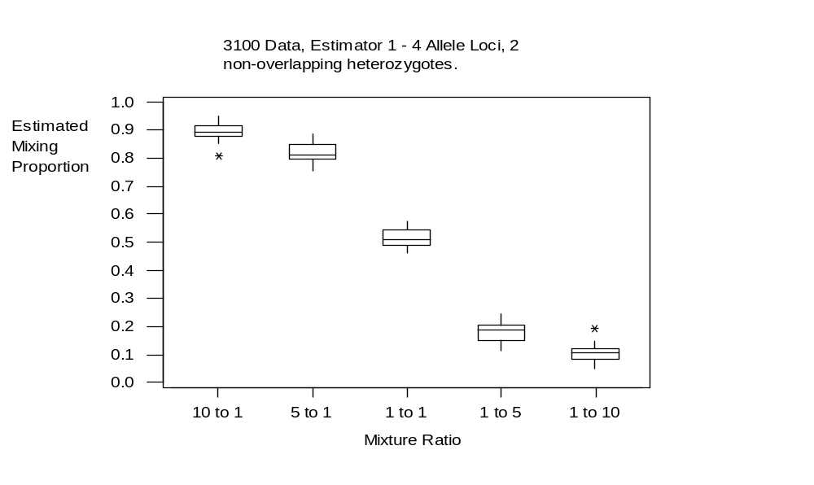Figures 1 & 2: Boxplots illustrating the behaviour of mixing proportion estimate formula 1.
In figures 1 and 2, the box and whisker plots describe the estimated mixing proportion data analysis, derived from the first data set (comparison data from 377 and 3100 instruments) for the four allelic peak mixing proportion estimate formula. As it can be seen, all the box plots are compact and don’t indicate any significant differences between the 377 and 3100 data sets, for any of the mixture ratios. The small compact boxes and the very short whiskers, indicate that the data here is very tightly around the median value, and thus displays very little variation. The 5 to 1 and 1 to 5 boxes show median lines that are not at a central point within the box itself, this indicates that the data is slightly skewed. Both the graphs above show a ‘mirroring’ effect in the data (illustrated by the positioning of the outliers at the 1 to 10 and 10 to 1 ratios). This is caused by the reversal of the data.

Figure 3 : Illustrating the spread or variance in the data.

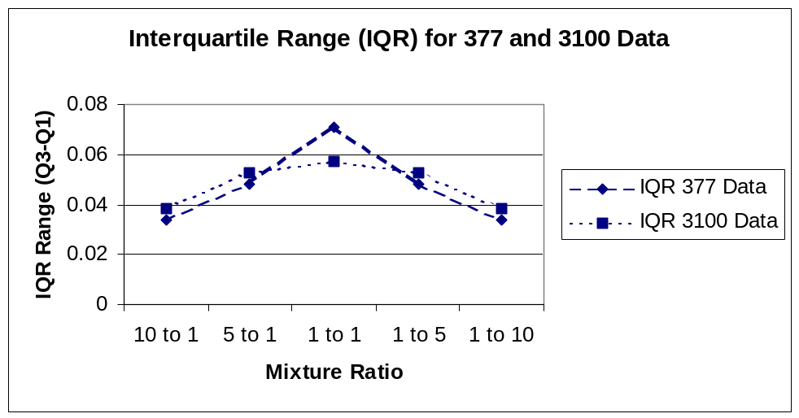

Figure 3 shows the spread or variance in the data. This is represented in the box plots as the size of the individual boxes. In the graph, the interquartile ranges (IQR) have been plotted (Appendix A, figure 33). The interquartile range is the difference between the upper and lower quartiles (the upper and lower box plot boundaries). This range spans the central half of the data and as with the median, the IQR is not disturbed by the presence of outliers. As the graph indicates, the 1 to 1 ratio shows the most variation in the data, however this maybe explained by only half the number of observations in this data set, when compared to the others.

The graph in figure 4 illustrates the median Mx values from both the 377 and 3100 instruments compared with the expected mixing proportion (Appendix A, figures 32 and 34). It clearly shows that the median Mx values from both instruments are very similar to the expected Mx values of the ratios.

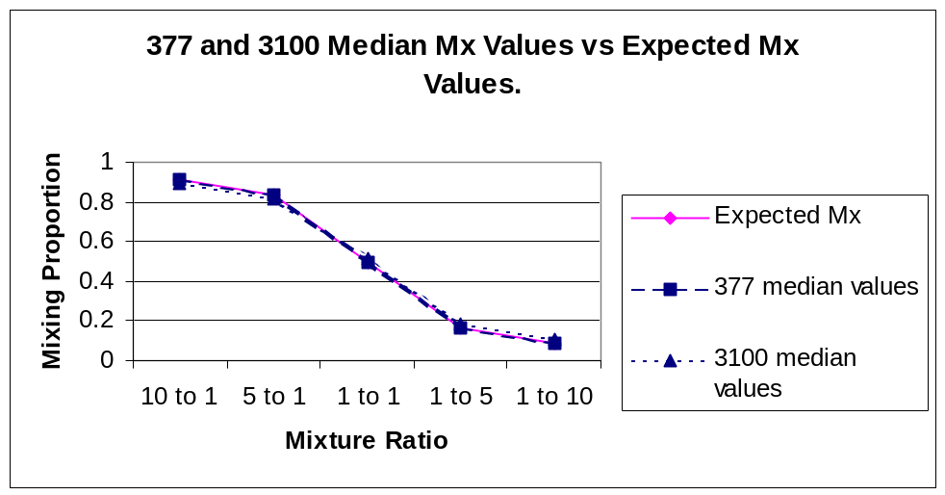(NB. Median values are used instead of mean values to avoid any inaccuracy caused by the inclusion of outliers.)

Figure 4: A comparison of median Mx values from the 377 and 3100 instrumentation with expected Mx values.

To determine the accuracy of the Mx estimate formula, a calculation was carried out in order to establish whether or not the formula was over or under-estimating the Mx value at each ratio (directional bias). To do this the observed median Mx value was subtracted from the expected Mx value, these results are displayed graphically below (Appendix A, figures 32 and 34).
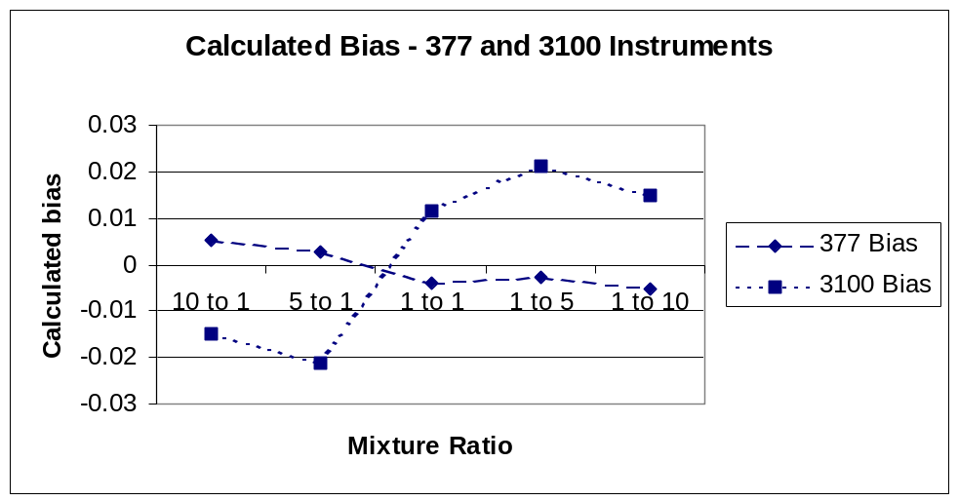

Figure 5: Calculated bias of the 377 and 3100 instruments.

As the graph in figure 5 illustrates, the 377 data has an over-estimation of Mx (positive bias) for the ratio of 10 to 1 and 5 to 1. However, for the ratios of 1 to 1, 1 to 5 and 1 to 10 the data gives under-estimation (negative bias) of Mx.
Conversely, the 3100 data shows an under-estimation (negative bias) of Mx for the 10 to 1 and 5 to 1 ratios, with an over-estimation (positive bias) of Mx for the 1 to 1, 1 to 5 and 1 to 10 ratios. The 377 data does appear to show less dramatic fluctuations when compared with the 3100 data. However, please take note of the scale on the y-axis, although the 3100 data does show an increase in bias, the scale shows that the magnitude of these biases are indeed very small. The bias calculation does not appear to have uncovered a trend in the data. It can be observed that with this particular data set, no one ratio gives a consistent positive or negative bias.

3.2.1.2 Data Set Two – ‘QLB’ Data Set.

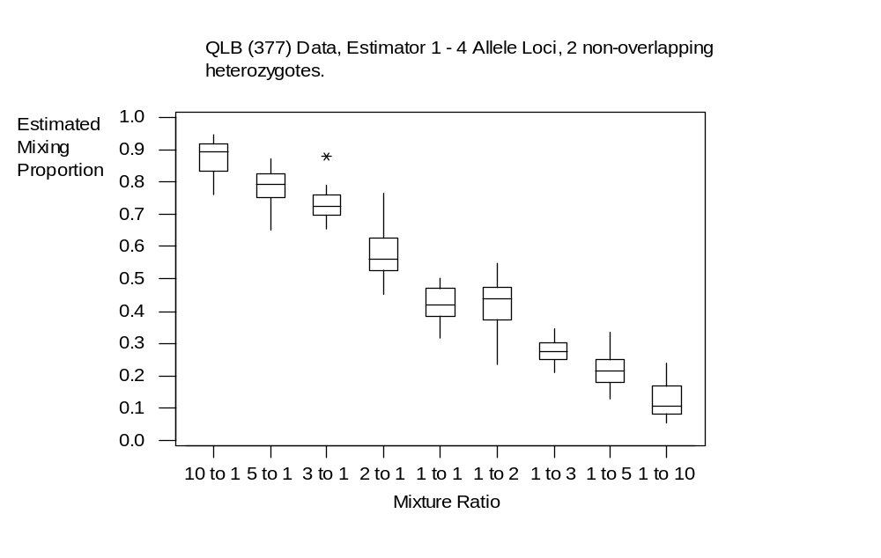Figure 6: A boxplot illustrating the behaviour of mixing proportion estimator 1.

Figure 6 illustrates the results for the ‘QLB’ data set for the four allelic peak mixing proportion estimate formulae. As it can be seen there are more mixture ratios within this data set and as before, all data have been reversed except for the 1 to 1 ratio (in order to avoid preferential choice of contributor, but this does cause a ‘mirroring’ effect in the data).
The first most apparent observation from the graph above are the different sized box plots for each mixture ratio. Box plots are designed so that the boxes span the central half of the data and that approximately 99.5% of observations fall inside the whiskers (for data from a Normal distribution). The differing box sizes and whisker lengths displayed by this data here, does indicate a wider variation in calculated mixing proportions to those observed in the previously discussed 377 and 3100 data sets. These differences maybe caused by sampling variations during experimental setup and are not thought to be due to Mx estimate formula inaccuracies.
The 1 to 10, 10 to 1, 1 to 2, 2 to 1 and 1 to 1 ratios all show median lines that are not at a central point within the box plots, this indicates that this data set is also slightly skewed.
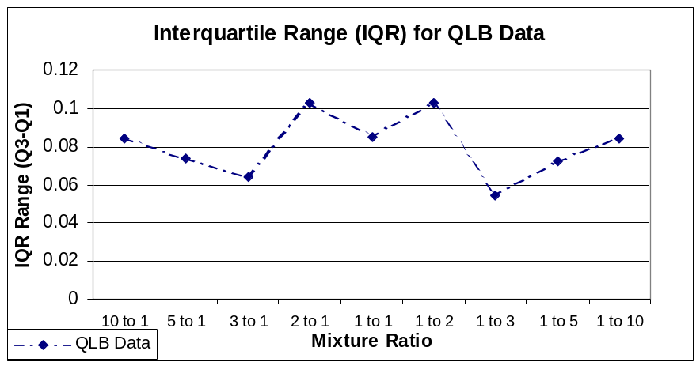This observed variation has been further examined by looking at the spread (the amount of variation) by calculating the interquartile ranges (Appendix A, figure 37), illustrated in the graph in figure 7.

Figure 7: Calculated interquartile ranges for the QLB data for Mx estimate formula 1.

It can be seen above that the 1 to 2 and 2 to 1 ratios have the largest IQRs and hence the largest data variances. Whereas, the ratios 1 to 3 and 3 to 1 have the smallest IQRs and display the smallest amount of data variation. The variation seen may be due to sampling differences during experimental set up rather than inconsistencies in the Mx estimate formula itself.
The other mixture ratios do appear to show variability between these two extremes.

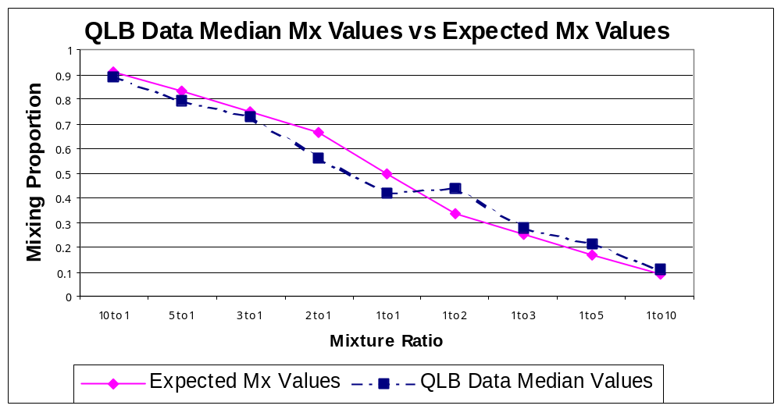Figure 8: A graph demonstrating QLB Mx median data plotted against expected Mx values.

The previous graph (figure 8) illustrates the median Mx values from the QLB data set compared with the expected mixing proportion. It clearly shows that the median Mx values from the QLB data are near to the expected Mx values of the ratios (Appendix A, figure 36). However, it can be seen that the QLB data median Mx values are under-estimates when compared to the expected Mx values, and as the ratios approach the 1 to 1 ratio, the differences become larger. Then, as the ratios move into the 1 to 2 range and progress to through to 1 to 10, the QLB data median Mx values change to become greater than the expected Mx values. These differences are represented in the graph below (figure 9), showing the differences between expected and observed Mx values (bias). This calculation is designed to indicate which Mx estimate formula either over- or under-estimates Mx (directional bias). As it can be seen, there is a lot of variation within this data set. The first half of the data, from 10 to 1 through to 1 to 1, show an under-estimation of the Mx value (negative bias). The second half of the data, from 1 to 2 through to 1 to
10 show an over-estimation of Mx (positive bias). This change is in no doubt caused, in part, by the reversal of the data (the ‘mirroring’ effect).

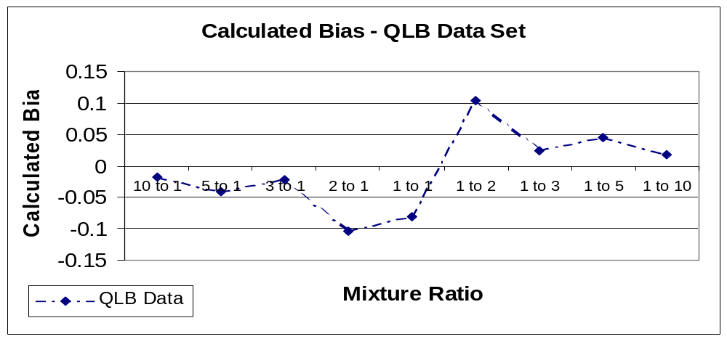Figure 9: Calculated bias for the QLB data set for Mx estimate formula 1.

The bias results from the QLB data set were compared with those from the 377 and 3100 data sets. It can be seen that the QLB data is closer in behaviour to that of the 3100 data (with the exception of the 1 to 1 ratio data), but is contradictory to that of the 377 data set. It is possible that a trend in mixture behaviour is starting to appear. A similar trend in mixing proportion data was suggested by the pilot study [1]. Here a trend seen in the pilot data suggested that when the expected mixing proportion is greater than 0.5 (ratios 2 to 1 – 10 to 1), the mixing proportion calculated is an under-estimate. However, when the expected mixing proportion is less than 0.5 (ratios 1 to 2 – 1 to 10), the mixing proportion calculated is an over- estimate.

The Mx estimate formula examined here, is regarded as being one of the most accurate and reliable due to the fact that it uses peak area data from loci comprising of two non-overlapping heterozygotes, with four distinct allelic peak areas. Therefore there is no doubt as to the size of each peak area (as none are shared between contributors). It is suggested that the variations seen within the data sets (especially the QLB data set), can be attributed to other factors, such as DNA concentration, sampling differences during PCR set up, PCR efficiency and performance and measurement of the PCR products, and not to the Mx estimate formula’s accuracy. It is recommended that four allelic peak loci be used in order to calculate the DNA profile’s mixing proportion.

3.2.2 Mixing Proportion Estimate Formula 2 – Three Allelic Peak Loci, Non-Overlapping Heterozygote and Homozygote.

The 377 and 3100 data sets had two loci (VWA and D8) that demonstrated non-overlapping heterozygote and homozygote alleles. The QLB (377) data set had various loci, throughout the ten profiles, that consisted of non-overlapping heterozygote and homozygote alleles. For clarity, the areas of the allelic peaks were designated A1, A2 and A3, when peak A1 comes from the homozygous contributor. The mixing proportion estimators used to calculate the mixing proportion () are as follows:

Contributor 1 Contributor 2 = 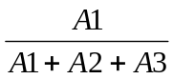
A1, A1 A2, A3

Contributor 1 Contributor 2 = 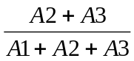
A2, A3 A1, A1

Similarly to the previous Mx estimate formula, these Mx estimate formulae are expected to accurately determine the mixing proportions at these loci as no alleles are shared.

In order to prevent a large amount of repetition in results, the graphical results for this and all other mixing proportion estimate formulae are listed in the appendices.

The box plots for both 377 and 3100 data sets (Appendix A, figures 38 and 41) were compact with short whiskers (very similar to Mx estimate formula 1). The calculated Mx estimates for both 377 and 3100 data appear to fit the expected mixing proportions very closely, however the box plots for the 3100 data are slightly bigger indicating more variation with this data set.
The interquartile ranges for both sets of data do follow the same trend (Appendix B, figures 40 and 43), that is ratios 10 to 1 and 1 to 10 have the smallest IQRs and thus the smallest variation. Whereas the 1 to 1 ratios show larger IQRs and so have more variation. A reasonable explanation for this would be that the 1 to 1 ratio has only half the number of observations in the data set when compared to the 1 to 10 and 10 to 1 ratios.
The bias for the calculated mixing proportion (Appendix B, figures 39 and 42) followed the same trend as seen in the pilot study, that is the ratios 10 to 1 and 5 to 1 (Mx larger than 0.5) gave an under-estimate for Mx for both 377 and 3100 data sets. Whereas the ratios 1 to 1 through to 1 to 10 (Mx 0.5 and less) gave an over-estimation of Mx. However, the differences in the calculated Mx and the expected Mx values were extremely small and not of significance.

The QLB data set gave box plots that were very variable (Appendix B, figure 44). Some gave short and compact box plots with outliers (1 to 10 and 10 to 1 ratios). Others had larger box plots with long whiskers (1 to 3 and 3 to 1 ratios), indicating a wider amount of variation with that data set (Appendix B, figure 46). The differences to the expected Mx values were calculated, some Mx values calculated were more accurate than others, ratios 1 to 3 and 3 to 1 being the most inaccurate, whereas 10 to 1 and 1 to 10 had the most similar Mx to that expected. Again here, these variations are reflected in the biases, which again seem to follow the trend suggested in the pilot study (Appendix B, figure 45). The biases in this case cannot however be explained in part by the number of observations within the data sets.

The full listing of tabulated data and graphical results can be found in appendix B.
3.2.3 Mixing Proportion Estimator 3 – Three Allelic Peak Loci, Two Heterozygotes Sharing One Allele.

Three loci (D18, D21 and THO1) in the 377 and 3100 data sets, consisted of two heterozygotes with one allele in common. The QLB data set had various loci throughout the ten profiles consisting of two heterozygotes sharing one allele. As before, the areas of the allelic peaks were designated A1, A2 and A3. Where peak A1 identifies the allele shared by both contributors. The Mx estimator used to calculate the estimated mixing proportion () was:

Contributor 1 Contributor 2
A1, A2 A1, A3

At these loci, the estimator will be expected to be less accurate at determining the estimated mixing proportion, because here one allele is shared between two heterozygotes. As one allele is shared, the allelic peak area donated by each contributor to the mixture cannot be accurately quantified. This imprecision will subsequently cause the estimator to be less accurate than others where all allelic peak areas are known.

The results for the 377 data do appear to fit the expected mixing proportions very closely (Appendix C, figure 48). Whereas the 3100 data tends to show larger biases with the same trends as seen with Mx estimator formula 1 (Appendix C, figure 51). Even though trends and differences in the expected values and the observed values for mixing proportion can be observed, they are minimal and insignificant.
The QLB (377) data has much larger biases and they follow the same trend seen in the pilot study, i.e. when the expected proportion is greater than 0.5, the estimator gives an under-estimate, while when the expected proportion is less than 0.5 it gives an over-estimate (Appendix C, figure 54).

The variance or spread in the 377 and 3100 data, shown by the interquartile range (IQR) indicates a degree of variability within these systems (Appendix C, figures 49 and 52). This is seen by the ratios 5 to 1 and 1 to 5 giving a smaller IQR, whereas the 10 to 1, 1 to 1 and 1 to 10 ratio IQR’s are comparable and constant.
The QLB (377) data show more variance within this data set (Appendix C, figure 55). Again the 5 to 1 and 1 to 5 ratios show less variance ranging through to the 10 to 1 and 1 to 10 ratios showing the most variance.

The full listing of tabulated data and graphical results can be found in appendix C.

3.2.4 Mixing Proportion Estimator 4 – Two Allelic Peak Loci, Two Non-Overlapping Homozygotes.

At these loci there are two homozygous alleles with no alleles being shared. The allelic peaks are designated A1 from contributor one and A2 from contributor two. The estimator used in order to calculate the estimated mixing proportion () for these loci is:

Contributor 1 Contributor 2
A1, A1 A2, A2

Only QLB (377) data (D3 alone) was available to use with this mixing proportion estimator. This Mx estimate formula would be expected to be more accurate and reliable, as no allelic peak areas are shared between contributor.
Even though this data set was small (comprising of data from one D3 locus), the results do display tendencies reflected in the other data sets and in the pilot study. There were only observations for the ratios 5 to 1, 3 to 1, 1 to 1, 1 to 3 and 1 to 5. The box plots did mirror each other (due mainly to the data being reversed) with the 3 to 1 and 1 to 3 ratios having the largest box plots, indicating a wider variability (Appendix D, figure 56). The calculated bias for each ratio was large, implying a large amount of variation within this system and calculated Mx values not particularly close to those expected (Appendix D, figures 57 and 58). These variations could possibly be due to a number of factors such as, the very small number of observations within this data set, all the data originating for one locus (D3), sampling errors during experimental set up and PCR performance and measuring differences.

The full listing of tabulated data and graphical results can be found in appendix D.

3.2.5 Mixing Proportion Estimator 5 – Two Allelic Peak Loci, One Heterozygote and One Homozygote Sharing One Allele.

Only one locus, Amelogenin, in the 377 and 3100 data sets provided information for this mixing proportion estimator. This locus consists of one heterozygote and one homozygote that have one allele in common.
As previously, the areas of the allelic peaks have been designated A1 and A2.

When A1 is the shared allele, the following estimator is applied:

Contributor 1 Contributor 2 = 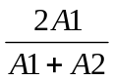
A1, A2 A2, A2

Or, when A2 is the shared allele, the following estimator is applied:

Contributor 1 Contributor 2 = 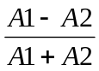
A1, A1 A1, A2

Similarly to Mx estimate formula 3, formula 5 will also be less accurate in determining the estimated mixing proportion, simply due to the inability to determine with any precision, the allelic peak area donated by contributors one and two.

The results for the 377 and 3100 data sets were comparable. The box plots were all of comparable size and shape, with very short whiskers when present (Appendix E, figures 59 and 62). The median lines indicated that the data was skewed. The calculated Mx values were very similar to those expected. The biases however, did not follow the trend seen before (Appendix E, figures 60 and 63). For both 377 and 3100 data sets, the ratios 5 to 1 and 1 to 10 showed an over-estimation of Mx (a negative bias) with the other ratios giving an over-estimation of Mx (a positive bias). The variability within both these data sets was very small and thus not of significance (Appendix E, figures 61 and 64).

The results for the QLB data set showed variable sized box plots, each with varying lengths of whiskers and again the median lines indicated that this data set was also skewed (Appendix E figure 65). The calculated Mx values differed from those expected and were reflected in the magnitude of the biases recorded (Appendix E, figure 66). Again the bias trend was similar to that seen in the pilot study, i.e. when the expected proportion is greater than 0.5 (2 to 1 up to 10 to 1), the Mx estimate gives an under-estimate for Mx. While when the expected proportion is less than 0.5 (1 to 2 up to 1 to 10) it gives an over-estimation of Mx. The variability with this data set was also larger to that seen with the 377 and 3100 data sets (Appendix E, figure 67). Again, this could be due to other factors unrelated to the individual Mx estimate formula used.

The full listing of tabulated data and graphical results can be found in appendix E.

3.3 Spread In Mixing Proportion Estimators – Full Data.

3.3.1 Data Set One – ‘377 & 3100’ Data Sets

The 377 data from all estimates were combined and plotted (with observed mixing proportion () versus mixture ratio), in order to allow observation of any bias in the mixing proportion estimates. This was repeated for the 3100 and QLB (377) data sets also.

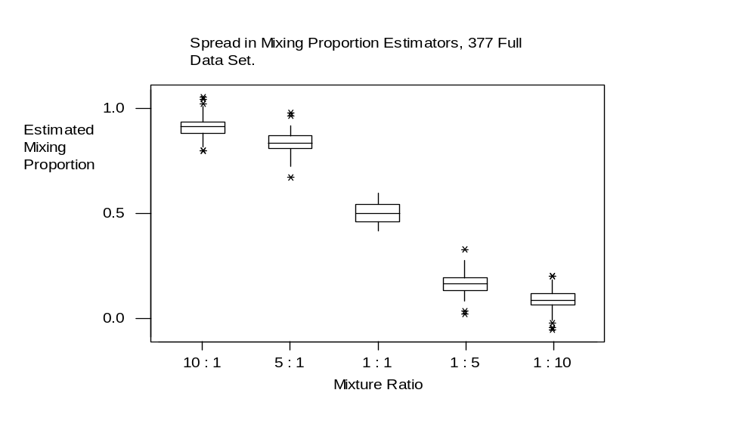Figure 10: Graphical representation of behaviour of mixing proportion () estimate formulae – 377 full data set.
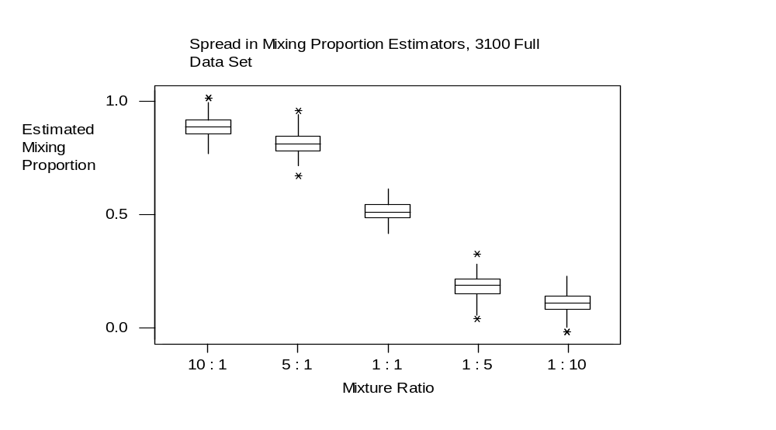Figure 11: Graphical representation of behaviour of mixing proportion () estimate formulae – 3100 full data set.
Figure 12: Graphical representation of calculated(median) values verses expected Mx values of the ratios (377 and 3100 data sets).
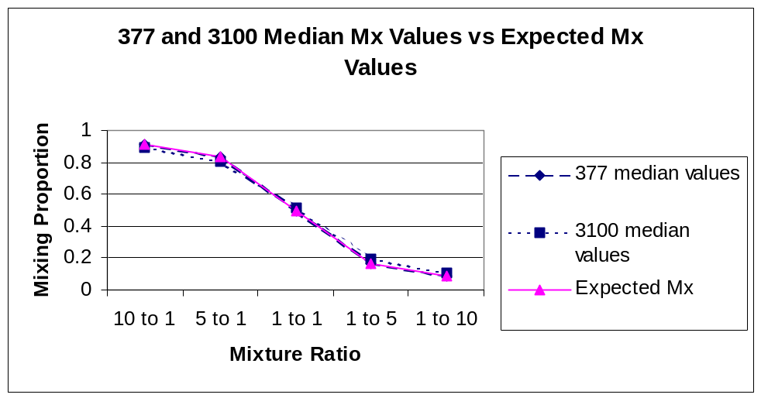

The 377 and 3100 full data sets both appear to closely fit the expected mixing proportions, indicting that these data sets are both accurate and that the different instruments are both performing equally.

Figure 13: Comparison of calculated bias - 377 and 3100 instrumentation.
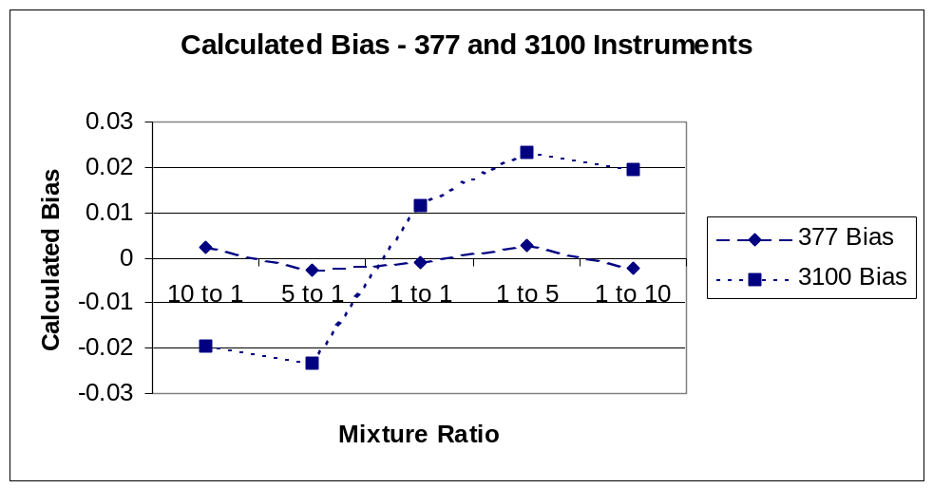

As figure 13 shows, the 377 data does not deviate away from zero very much at all, indicating that this data set has allowed very accurate calculations of the mixing proportions for each ratio. Conversely, the 3100 data, with samples identical to that run on the 377 instrument, shows more deviations away from zero at each ratio. These differences could be due to varying experimental factors, such as experimental sampling (sampling a quantity to be run on 3100 instrument) and also the 3100 instrument itself. However, these differences in the results are not significantly large enough to be consistent with unreliable Mx estimate formulae.
3.3.2 Data Set Two – ‘QLB’ Data Set

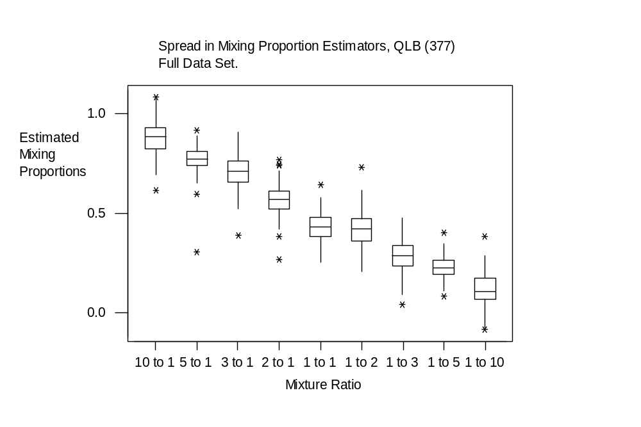Figure 14: Graphical representation of behaviour of mixing proportion () estimate formulae – QLB full data set.

Figure 15: Graphical representation of QLB data calculated(median) values verses expected Mx values of the ratios.
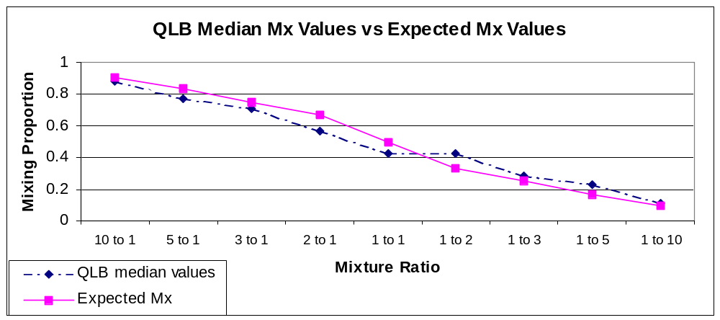
The QLB (377) data also displays the same trend as seen in the pilot study (as indeed seen throughout all estimators examined). That is, when the expected proportion is greater than 0.5 (ratio of 1:1) the estimator will give an under-estimate (negative bias), while when the expected proportion is less than 0.5 it gives an over-estimation (positive bias). This is visually more evident in the graph of calculated bias verses ratio (see below).
However, although this could be entirely due to the estimators involved, it could and is suspected to involve experimental inconsistencies (PCR performance, sampling differences and measurement differences) influencing these results.

Figure 16: A graph plotting calculated bias verses ratios, showing the fluctuations in calculated Mx.
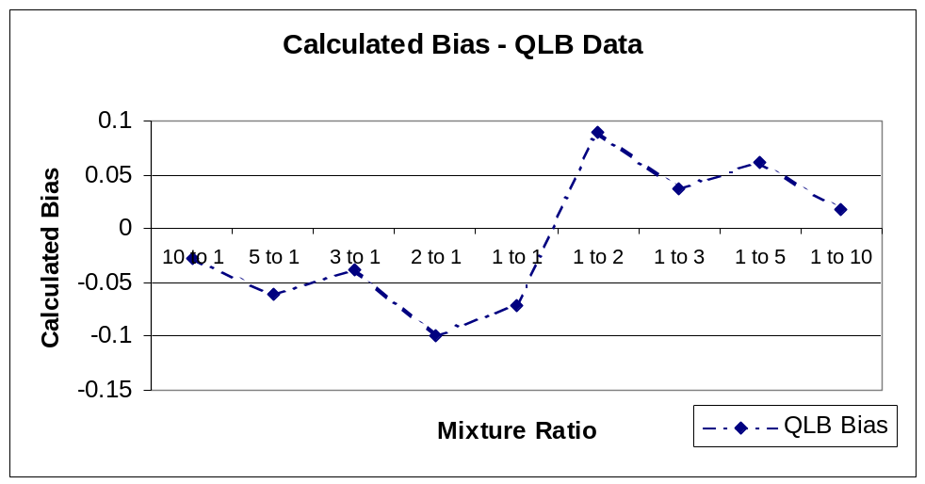

The full listing of tabulated data for 377, 3100 and QLB data sets can be found in appendix F.

3.4 Behaviour of Mixing Proportion Estimate Formulae - A Summary

The results in this study so far have not give a completely clear cut answer to our question into the accuracy of the data and mixing proportion estimate formulae. The 377 data set gave accurately calculated mixing proportion estimates for each formula examined. This was in contradiction to those given by the 3100 and QLB data, which followed the same trend as seen in the initial study (Triggs and Buckleton [1] ). This study found that when the expected proportion is greater than 0.5 (10 to 1 through to 2 to 1 ratios), the estimate formula gives an under-estimation of Mx. While when the expected proportion is less than 0.5 (1 to 2 through to 1 to 10 ratios) it gave an over-estimation of Mx. However, it can be inferred that the difference in Mx behaviour is not completely reliant upon the performance of the Mx estimate formulae. Moreover, it is directly dependent upon the initial amount of DNA, accuracy of ratio construction, PCR performance and measurement of allelic peak areas. The larger the initial DNA concentration and the closer to a 1 to 1 ratio (Mx = 0.5) the more accurate the Mx calculation will be, this has more to do with actual experimental set up than the performance of individual mixing proportion estimate formulae. Therefore it can be summarised that each Mx estimate formulae is capable of supplying accurate Mx estimations to be used in the interpretation of DNA mixtures.

3.5 Individual Mixing Proportion Estimate Formulae Effects

In order to examine the precision of each individual mixing proportion estimator, the variance of each formula was plotted on box and whisker plots. To construct the plots any bias and variation originating from the mixture ratios must first be removed by subtracting the median mixing proportion at each nominal ratio, thus creating mixing proportion residual data. This in effect ‘centred’ the data around zero. And allowed the spread or variance of the data sets to be visualised. The data were then group together according to the estimator used.

NB: Key to graphs:
Estimator 1 = 2 non-overlapping heterozygotes
Estimator 2 = non-overlapping heterozygote & homozygote
Estimator 3 = 2 heterozygotes sharing 1 allele
Estimator 4 = 2 non-overlapping homozygotes
Estimator 5 = 1 heterozygote & 1 homozygote sharing 1 allele

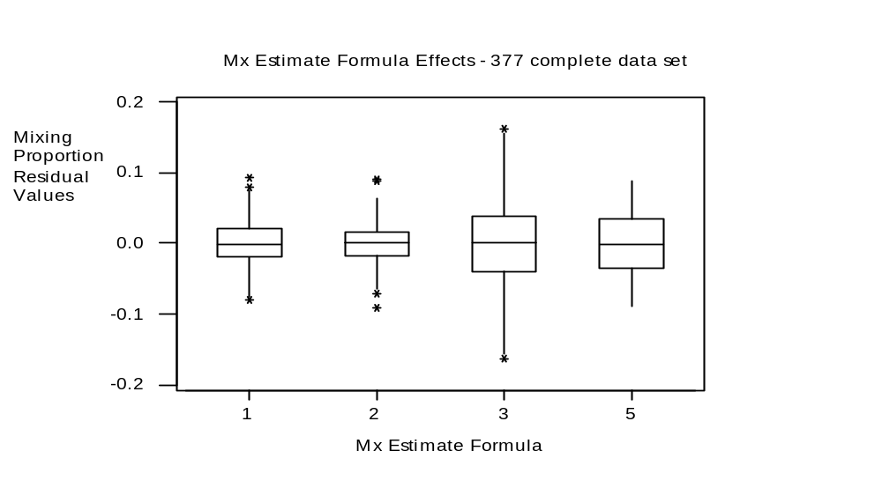Figure 17: Graphical representation of the behaviour of mixing proportion estimate formulae, 377 data.
Figure 17 and subsequent figures 18 and 19 illustrate box plots displaying mixing proportion residual value against individual Mx estimate formula. Due to the allelic combinations forming the mixed profiles studied, no estimate formula 4 was used during the analysis of this data (however, this formula was included in the QLB data set) and therefore no results are represented here for this formula. Each box plot is centred on zero, indicating that no bias has been introduced by the individual Mx estimate formula. The variance can be seen on the graph as the spread or area of the boxes plotted. Thus, estimate formula 3 (2 heterozygotes sharing 1 allele) shows a higher degree of variance when compared to estimate formula 1 (2 non-overlapping heterozygotes) and 2 (non-overlapping heterozygote & homozygote). This result is what would be expected, i.e. in cases where all the allelic peak areas can be unequivocally determined and measured (estimate formulae 1,2 and 4) these are expected to have the smallest variance. In cases where one allelic peak area is shared between both contributors and are therefore less accurately determined (estimate formulae 3 and 5) these are expected to have larger variances. This occurrence can be observed in all the data sets.
Figures 18: Graphical representation of the behaviour of mixing proportion estimate formulae, 3100 data.
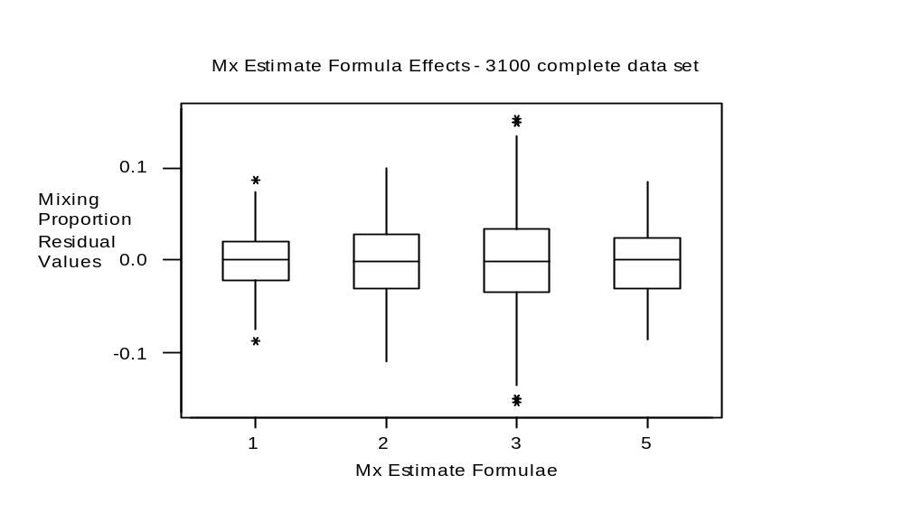
Figure 19: Graphical representation of the behaviour of mixing proportion estimate formulae, QLB data.
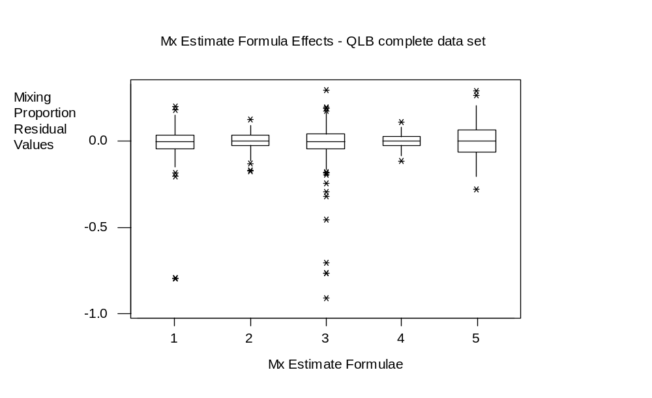

The box plots for the QLB data (figure 19) do appear to have smaller variances than the 377 and 300 data sets. This is in part due to the scaling on the graph’s y-axis and also to the larger number of observations within this data set.

Figure 20: Variance determined by interquartile range within 377, 3100 and QLB data sets.

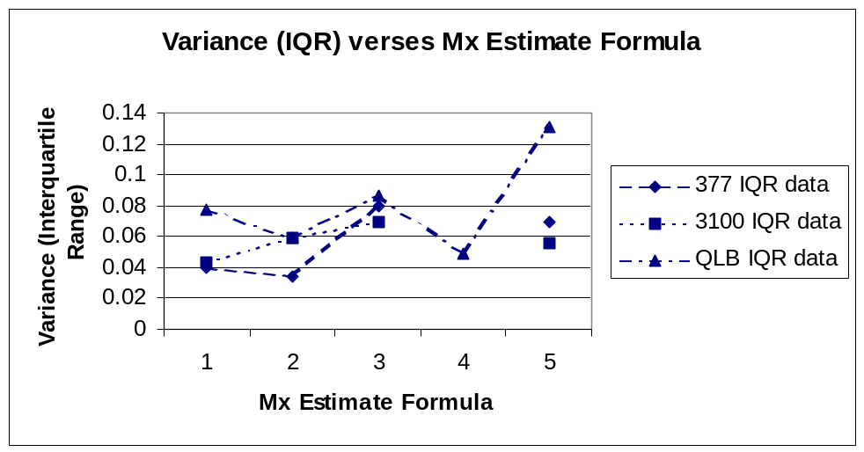

The graph above (figure 20) uses interquartile range to indicate variance, that is the larger the IQR the larger the variance. The QLB data set appears to have a slightly larger variance as compared with the 377 and 3100 data sets, and seems to follow the predicted variance behaviour of the estimate formulae seen in the box and whisker plots. This behaviour is also more evident in the QLB data set as it is much larger than the 377 and 3100 data sets.

The full listing of tabulated data for the 377, 3100 and QLB data sets can be found in appendix G.

3.5.1 Summary

Mixing proportion estimate formulae 1, 2 and 4 appear to be more accurate, reliable and less prone to variation. This is due to them using peak area information from unequivocally identified and measured allelic peaks, as none of these Mx estimate formula apply to mixtures where alleles are shared between contributors. However, Mx estimate formulae 3 and 5 do show variances due to the peak area data being initially less accurate, due to one allelic peak area being shared between both contributors, and so these peak areas cannot be determined precisely. Although variances have been seen between Mx estimate formulae, the data analysed here demonstrates that they are reliable.

3.6 Locus Effects

The Mx residual data were divided into individual loci and plotted on box and whisker plots in order to show any variances resulting from any effect caused by the individual loci. The results did indicate that each locus did behave differently, each with a different amount of variation (indicated by the departure of the new median value away from zero).

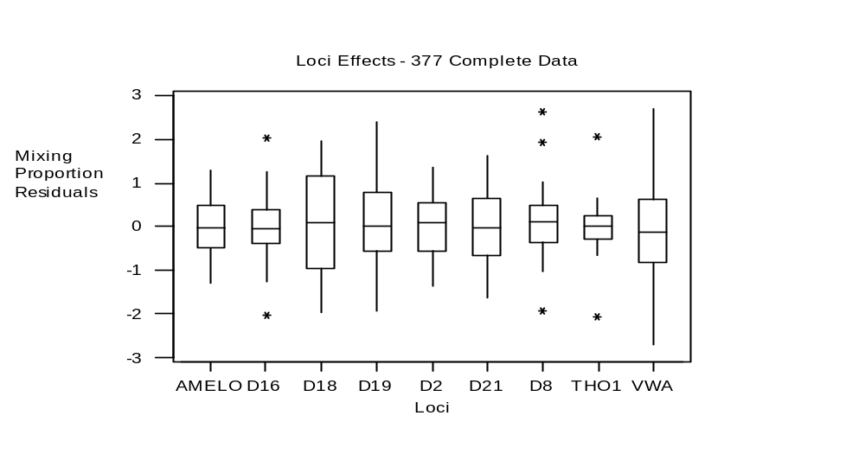Figure 21: Graphical representation of the behaviour of locus and mixing proportion – 377 data.

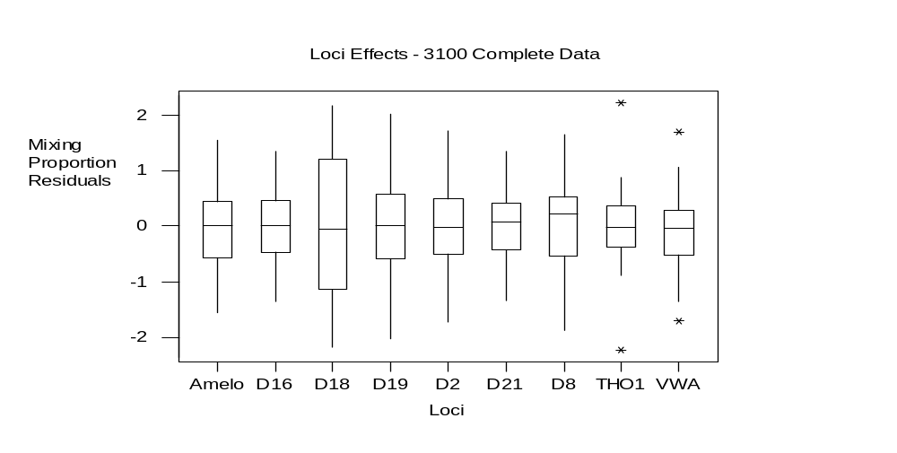Figure 22: Graphical representation of the behaviour of locus and mixing proportion – 3100 data.
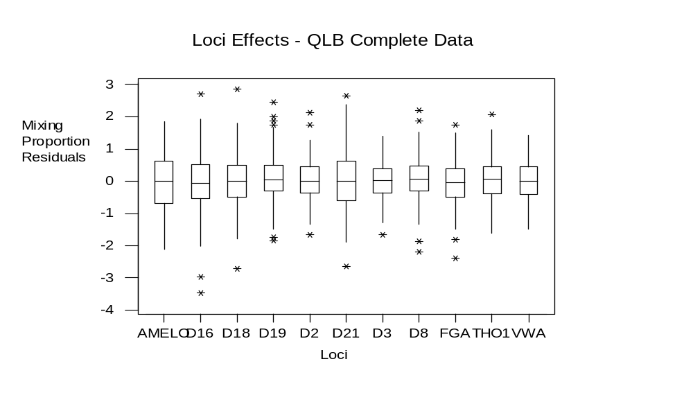
Figure 23: Graphical representation of the behaviour of locus and mixing proportion – QLB data.

The results show that most of the loci appear to be centred on zero, indicating that the mixing proportion at those loci is estimated accurately and no bias has been introduced by the individual loci. As the medians move further away from zero, it indicates that the mixing proportion estimates are becoming either over-estimates (e.g. D8 in the 377 and 3100 data sets) or under-estimates (e.g. VWA in the 377 and 3100 data sets and D16 in the QLB (377) data set).
The differences in the interquartile ranges (IQR) demonstrate the variation of mixing proportion estimation within a locus.

Figure 24: Graph depicting interquartile range verses individual loci.
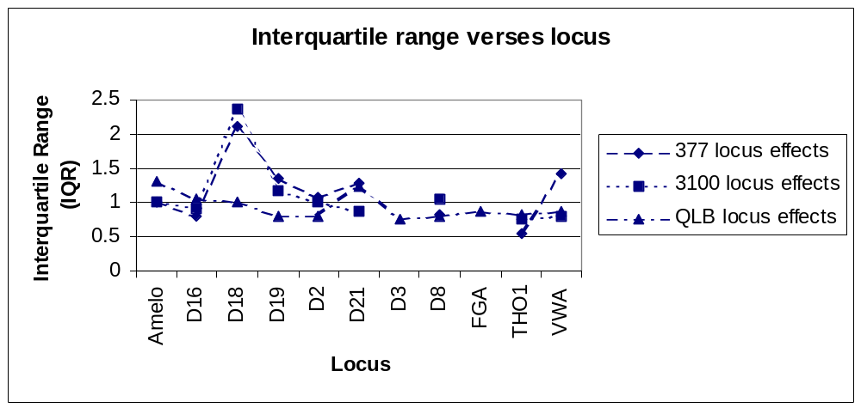
The full listing of tabulated data for the 377, 3100 and QLB data sets can be found in appendix H.
3.6.1 Summary

The graphical display of interquartile ranges verses loci indicates the degree of variation at each locus. As it can be seen the QLB data gives a smaller amount of variation (within + or – 0.5 centred on 1), implying that with this data set, no specific locus causes variation.
This too is also the case for the 377 and 3100 data, with the exception of the D18 locus. This locus shows a larger amount of variance compared with each of the other loci. This could quite possibly be due to the fact that D18 is indeed a high molecular weight locus, but no large variances are seen at the other high molecular loci (e.g. D2 and FGA). However this variance could have originated from the construction of the two-person mixture used in this data set. The D18 locus here only uses Mx estimate formula 3, which is for a three allelic peak loci constructed from two heterozygotes sharing one allele. As there is a shared allele at this position, an amount of variance will be introduced as the precise amount of allelic peak area donated by each contributor will be unknown. The 377 and 3100 data sets also only comprise of a single two-person mixture and so only one Mx estimate formula will be used at each locus, for every different ratio. Whereas the QLB data set comprises of many different two-person mixtures, each with a different allelic arrangement at each locus. Therefore different Mx estimate formulae will be used for each locus throughout the whole data set, and so reduce the amount of variance seen when the entire data set is combined (as here).
A further study, with a larger data set using many different allelic combinations at each locus, would be of great use to gain more insight into a potential locus effect. A possible hypothesis that could be investigated would be to find whether or not larger molecular weight alleles provide more variation. However, the data set here indicates that no one specific locus causes an effect and so any four allelic peak locus could be used to calculate the profile’s Mx.

3.7 Concentration Effects

Only the QLB data set was constructed with different DNA concentrations. The DNA concentrations consisted of 0.5ng, 1.0ng, 1.5ng and 2.0ng. The Mx residual values were used in order to remove any bias and variation, originating from the different mixture ratios, from the data set.

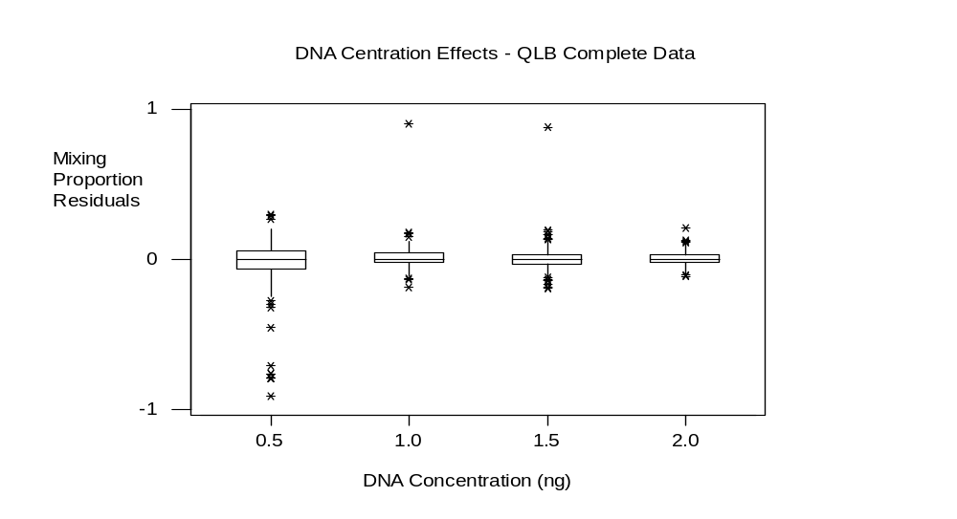Figure 25: Graphical representation of DNA concentration effects upon mixing proportion (QLB data only).
Figure 26: A graph of Mx residual median values plotted against DNA concentration used to construct the two-person DNA mixed profiles.
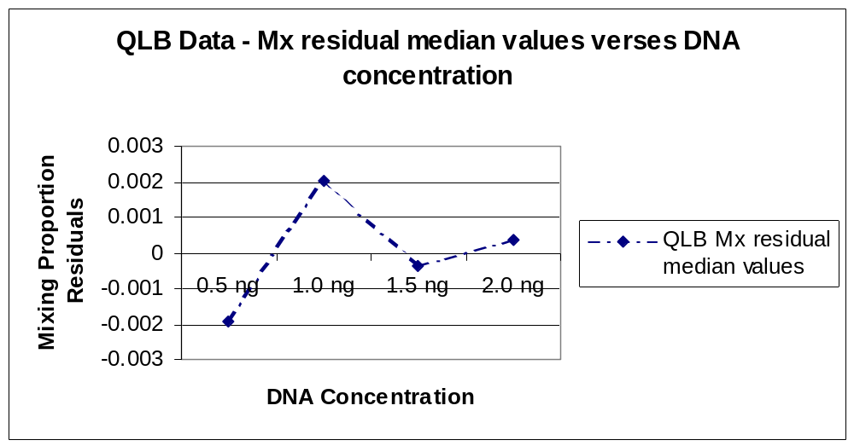
Figures 25 and 26 shows the mixing proportion residual values plotted against DNA concentration. The y-axis scale on figure 26 is a little misleading at first glance, however on closer inspection it can be seen that the data is all centred around zero. Thus indicating that there is no real bias introduced into the mixing proportion calculation when the DNA concentrations are varied.

Figure 27: A graph plotted to show interquartile range verses DNA concentration.

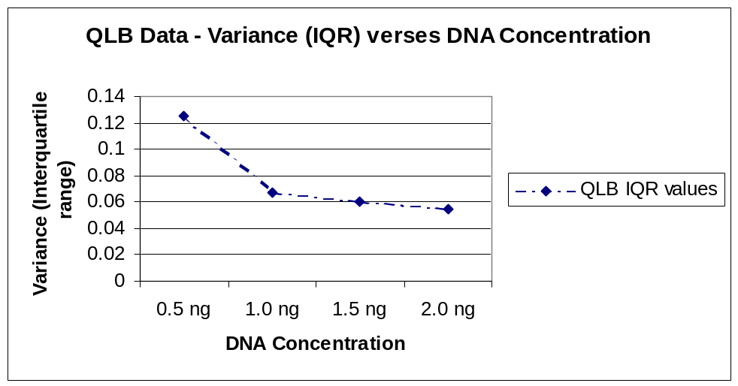

The above graph (figure 27) shows the variance, indicated by the interquartile ranges, introduced into the system by DNA concentration. As the results show, an increase in variance is introduced with the low 0.5ng DNA concentration, but as the DNA concentration increases, the variance reduces. The reason for the variance at the low DNA concentration is possibly due to a reduction in PCR performance due to the low DNA concentration and / or sampling error while constructing the mixture ratios.

The full listing of tabulated data for the 377, 3100 and QLB data sets can be found in appendix I.

3.7.1 Summary

The results show that when DNA concentrations are varied no bias is introduced to the mixing proportion calculation. However, as DNA concentrations reduce, it appears that the variance within the system does increase slightly. This variation could be a direct result of sampling differences during mixture construction and/or reduced PCR performance due to the low DNA concentrations.
Results did show that in 10:1 ratio mixtures created from low DNA concentrations (0.5ng) the minor contributor alleles would fail to amplify at varying allelic positions in every case. However, these amplification failures were not isolated totally to the low DNA concentrations. Minor component amplification failure of some alleles has been observed at DNA concentrations of 2 and 1ng and at ratios of 10:1 and 5:1. This implies that at larger ratios with small DNA concentrations it is reasonable to assume that minor allelic components may not be amplified efficiently and therefore not represented in the results – this has obvious repercussions for casework samples and the interpretation of results.
This study does not indicate how lower DNA concentrations will behave. As the results appear to show an increase in variance with lowering of DNA concentration, it could be hypothesized that as the DNA concentration decreases, there is an increase in the variance being introduced into the system. This could be further investigated.
4. Review of the +/- 0.35 Mixing Proportion Tolerance Window

This section of study examined the occurrence of apparent ratio ‘switching’ of loci within one single mixed profile. ‘Switching’ can be observed in ratios very close to 1 to 1, when the ‘minor’ contributor amplifies to become the ‘major’ contributor or vice versa. This was considered during the creation of the mixture interpretation software. The original report on the software (built around the mixing proportion estimate formulae) was authored by M.R.Bill and I.K.Rattle 2002 [1]. This report recommended “inclusion of a rule (or minor modification of the program) to consider the ’switch’ of combinations for mixtures with an Mx between 35-50%. This would take account of PCR variation and preferential degradation.” This recommendation was followed and a mixing proportion tolerance of +/- 0.35 was introduced for the second version of the software, applying to all Mx estimates.

The QLB data set analysed previously was used in this study. The mixing proportion for each individual locus was calculated using the mixing proportion estimate formulae. Plots were then drawn showing calculated mixing proportion against actual observations per locus. The graphs were plotted in order to observe any Mx ‘switching’ and also any particular variances introduced by either DNA concentration and / or individual loci.

Figure 28: A graph showing a 1 to 1 ratio (Mx = 0.5) with calculated mixing proportion plotted against the actual observations per locus, broken down by DNA concentration.
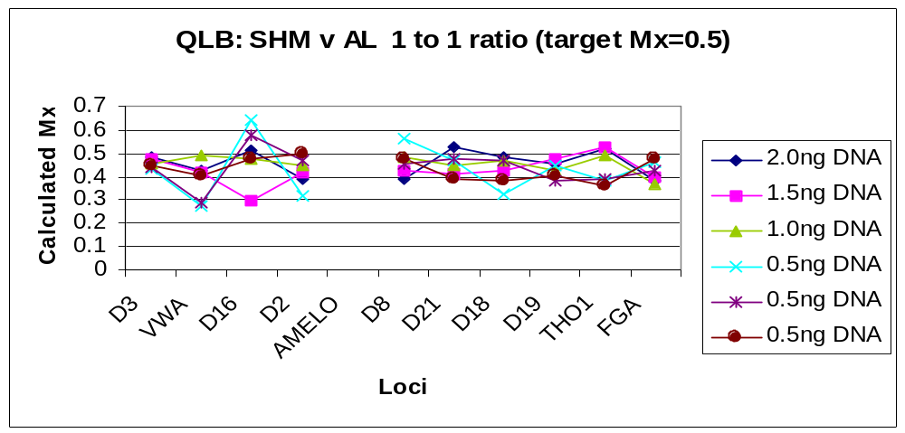

From the above graph (figure 28) it can be seen that there are fluctuations in Mx values around the value of 0.5. The highest Mx value is 0.641 (tending towards a ratio change of 2 to 1) and originates from a 0.5ng DNA concentration at D16. The lowest Mx value again originates from a 0.5ng DNA concentration sample at VWA the Mx value is 0.288 (tending towards a ratio change of 1 to 2.5). Looking at the graph, as the Mx values get larger and move away from 0.5 (a corresponding ratio of 1 to 1) towards an Mx of 0.7, they start to change towards a ratio ‘switch’ of 2 to 1. Also as the Mx values become smaller, moving towards an Mx value of 0.3, the ratio changes towards being a 1 to 2.
With this particular set of sample data the variation seen between the observed Mx and Mx is +0.141 and –0.212, both values fall well within the proposed + / - 0.35 tolerance window of 0.15 to 0.85.
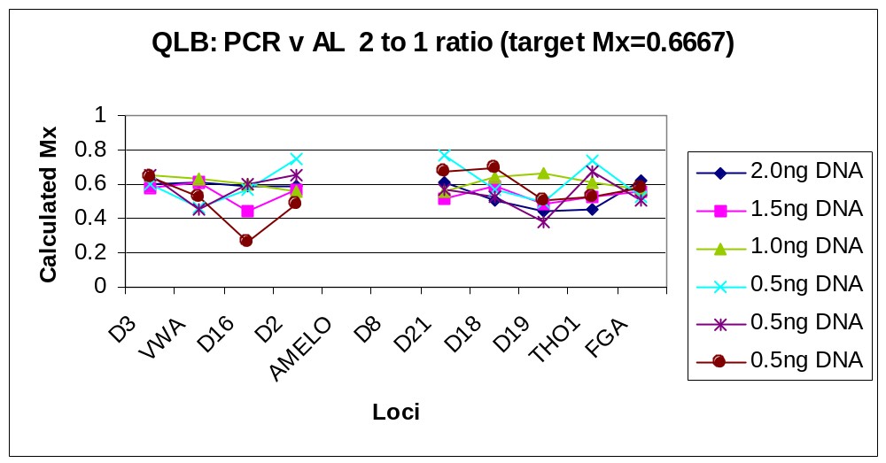Figure 29: A graph showing a 2 to 1 ratio (Mx = 0.6667) with calculated mixing proportion plotted against the actual observations per locus, broken down by DNA concentration.

Figure 29 shows variances around the Mx of 0.6667. The lowest and highest points again originate from profiles created using 0.5 ng DNA. The lowest Mx is 0.267, corresponding to a ratio change of 1 to 2.75, this originates from D16 locus with 0.5ng DNA. The highest Mx is 0.746, corresponding to a ratio change of 3 to 1, this originates from D2 locus with 0.5ng DNA. The majority of the Mx values fall within the +/- 0.35 Mx tolerance window of 0.3167 to 1.0 (an Mx of 1 indicates any combinations are viable) however, the lowest point (D16 Mx = 0.267) fall outside of this window and thus would be rejected by the software.

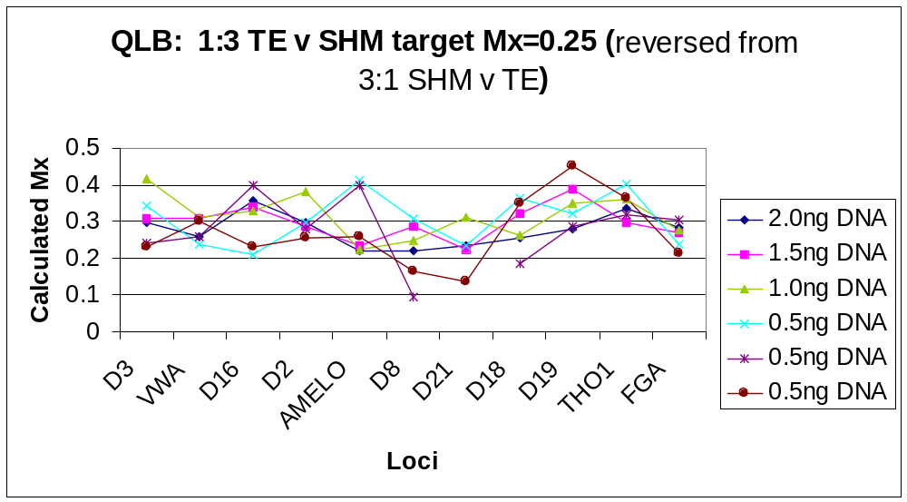Figure 30: A graph showing a 1 to 3 ratio (Mx = 0.25) with calculated mixing proportion plotted against the actual observations per locus, broken down by DNA concentration.
The previous graph (figure 30), with a ratio of 1 to 3, shows variances around the Mx of 0.25. As with the former graphs, the lowest and highest points originate from profiles created using 0.5 ng DNA. The lowest Mx is 0.095, corresponding to a ratio change of 1 to 9.5, this originates from D8 locus with 0.5ng DNA. The highest Mx is 0.452, corresponding to a ratio change of almost 1 to 1, this originates from D19 locus with 0.5ng DNA. All of the Mx values fall within the +/- 0.35 Mx tolerance window of 0.0 to 0.6.

4.1 Summary

Observations from this study have found that loci within one mixed profile fluctuate around the ‘expected mixing proportion’ and the calculated mixing proportion is a mean derived from all individual loci within that profile. The data analysed here did not fall outside of the + or – 0.35 (35%) tolerance window introduced into the software. In fact the majority of data fell inside a window of + or – 0.25.The + or – 0.35 Mx tolerance window set within the software program was designed to prevent any loss of potential allelic combinations and this tolerance window is recommended for casework applications. From the data analysed here, the + or – 0.35 tolerance looks to be a little cautious. However in order to accommodate the wide variations see in casework samples, this tolerance window is of a reasonable size in order to the job it was designed for, that is, to prevent the loss of potential allelic combinations.
Further investigation into the ‘switching’ of mixing proportions (or ratios) could be carried out in order to define the frequency of this occurrence and also under what conditions this type of event will happen.

5. Heterozygous Balance in Two-Person DNA Mixed Profiles

This has been examined in order to verify how alleles behave a mixed profile situation. Heterozygous imbalance, or preferential amplification, occurs when one allele at a heterozygous locus is amplified more efficiently than the other allele and is characterised by the alleles having unbalanced peak heights and areas. In single DNA profiles it is unusual to observe an imbalance of heterozygotes where the peak are of the allele having the lowest signal is less than 60% of the size of its companion (the allele with that largest signal). Also, amplification of high molecular weight alleles are generally less efficient than low molecular weight alleles (P. Gill et al, 1997 [5]). These two observations were investigated with the mixed profile data, in order to define whether or not these observations still hold true when DNA profiles are within a mixture.
The peak area data had no adjustments made to it to compensate for stutter and n bands. As these occurrences are direct results of allele amplification, their occurrence will affect the allelic peak area. As no compensation has been made for their occurrence, this could affect the amplification balance of heterozygote alleles and thus will cause more variation to be seen in this study.

Peak area imbalance was investigated by calculating the proportion of the smallest peak area relative to the largest peak, irrespective of molecular weight (peak area smallest peak divided by peak area largest peak) thus all results will be between 0 and 1. This data was subsequently listed and grouped depending upon the number of base pair differences between the smallest and largest allelic peaks. In order to construct a simple graph in order to observe any trend in the data, the mean value of each group was calculated and the graph below (figure 32) plotted:

Figure 31: A graph showing mean heterozygous balance verses base pair separation.
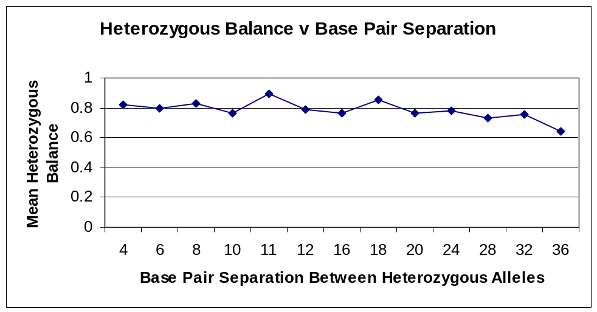
Figure 31shows a plot of mean heterozygous balance verses base pair separation (the number of base pairs separating both alleles). The scale on the y-axis corresponds to the proportion of the smallest allelic peak in relation to its larger partnering allelic peak. Here, a value of one here indicates that both alleles are of equal size and perfectly balanced, whereas a value of zero indicates one allele has dropped out completely. From the graph it can be observed that as the number of base pairs separating the allelic partners increases, the heterozygous balance decreases and moves towards a proportion of 0.6 (60%) – a figure observed in single profile data (P. Gill et al, 1997 [6]). Thus the more separation there is between the two heterozygous alleles, the less efficiently the larger allele amplifies and the heterozygous balance decreases.

5.1 Summary

The results observed here indicate that the more base pair separation there is between the two partnering heterozygous alleles, the less efficiently the larger allele amplifies and the heterozygous balance decreases. These results indicate that alleles behave similarly whether in a mixed or single profile and although the heterozygous balance does decrease, it does not fall below the FSS recommended heterozygous balance guideline of 0.6 (60%).
As stated previously, further investigation into allelic behaviour within a two-person mixture could be carried out in order to find what effects such a mixture has on the amplification rate of alleles at an individual locus.
6. Performance Comparison of Applied Biosystems’ 377 and 3100 Instrumentation - Summary

Throughout the analysis of the 377 and 3100 instrument data during this study, no substantial differences between these two data sets were observed and nothing that would imply a significant difference in measurement and information output. The mixing proportion estimate formulae analysis highlight the similarity of the two instrument systems and indicates that results produced on both these instrument platforms are comparable.
With these data sets in mind, this study shows that the output from the 377 and 3100 instruments are equivalent and comparable in performance of detection and measurement of two-person mixed DNA profile data, producing reliable results for use with the mixing proportion estimate formulae. Further output graphs and data have been listed in the appendices of this report.

7. Conclusion

7.1 Behaviour of Mixing Proportion Estimate Formula

The scope of this report was to continue and extend the preliminary analysis into the behaviour of the mixing proportion estimate formulae (Triggs and Buckleton, 2002, personal communications). The findings from the preliminary analysis gave more gravity to the expectation that formulae that use data obtained from shared allelic peak areas are not as accurate and more prone to variation, than formulae where data originates from peak area information that is unequivocally identified and determined.
The preliminary analysis also highlighted a trend seen in the initial data set examined. The trend followed the pattern of when the mixing proportion is greater than 0.5 (ratio range of 2:1 to 10:1) the mixing proportion calculated is an under-estimation. In addition, as the mixing proportion becomes less than 0.5 (ratio range of 1:2 to 1:10) the mixing proportion calculated is an over-estimation.
The data in this extended study also identified with both the expectations of Mx estimate formulae behaviour and the trend observed. However, this behaviour cannot be completely reliant upon the performance of the Mx estimate formulae alone. Although variances have been seen between Mx estimate formulae, it seems that the major sources of inaccuracy are directly dependent upon the initial concentration of DNA, sampling differences during PCR set up, PCR efficiency and performance (these are directly linked to the amount and quality of DNA template).
The findings from this study do imply that the Mx estimate formulae are robust and reliable.

7.2 Review of the +/- 0.35 Mixing Proportion Tolerance Window

A review of the + or – 0.35 Mx tolerance window was undertaken, in order to examine the occurrence of ‘ratio switching’ of loci within a single mixed profile and the suitability of the + or – 0.35 value. It was found that Mx values at each locus within a single mixed profile in many instances are different to the overall mean Mx for that individual profile (and also the ratio). These differences possibly being the result of sampling differences during experimental construction and individual locus PCR performance differences. The tolerance window was proposed in order to accommodate these fluctuations.
The data analysed here did not fall outside of the + or – 0.35 (35%) tolerance window introduced into the software, in fact the majority of data fell inside a window of + or – 0.25.
The + or – 0.35 Mx tolerance window was set within the software program in order to prevent any loss of potential allelic combinations. From the data analysed here, the + or – 0.35 tolerance is proved to be of a reasonable size in order to the job it was designed for, that is, to prevent the loss of potential allelic combinations.

7.3 Heterozygous Balance in Two-Person DNA Mixed Profiles

The heterozygous balance within two-person mixed DNA profiles was examined in order to determine if allelic amplification behaviour was changed due to the presence of a mixture.
The results observed in this study indicated that the more separation there is between the two heterozygous alleles, the less efficiently the larger allele amplifies and the heterozygous balance decreases. These observations indicate that alleles behave similarly whether in a mixed or single profile and although the heterozygous balance does decrease, it does not fall below the FSS recommended heterozygous balance guideline of 0.6 (60%).

7.4 Performance Comparison of Applied Biosystems’ 377 and 3100 Instrumentation.

A performance comparison was made between the Applied Biosystems 377 and 3100 instruments. The study showed that there were subtle differences but nothing that would be considered significant. The results demonstrate that outputs from the 377 and 3100 instruments are equivalent and comparable in performance detection and measurement of two-person mixed DNA profile data, producing reliable results for use with the Mx estimate formulae.

The overall results from the different facets of this study indicate that the current FSS guidelines set out are justified and are applicable. It is hope that this comprehensive study will provide a valuable resource to support the future development of DNA mixtures analysis in the FSS.

8. Acknowledgements

I would like to acknowledge John Buckleton and Chris Triggs for their initial statistical work carried out during the pilot study, into the behaviour of the mixing proportion estimate formulae.
This project expanded and added to their initial work, examining two different data sets. I would like to thank and acknowledge Christophe Champod and Peter Gill for their guidance and help throughout this project.

9. References

[1] C. Triggs and J. Buckleton, personal communications, 2001.

[2] M. Bill and I. Rattle, Validation of Pendulum Mixture Interpretation Package. Internal FSS Report 2002.

[3] K. Tsang, Mixtures Study Using The AB 3100 Instrument, K.Tsang, Internal FSS Report 2002.

[4] P. Gill, R. Sparkes, R. Pinchin, T. Clayton, J. Whitaker, J. Buckleton, Interpreting Simple STR Mixtures Using Allele Peak Areas. Forensic Science International, 91 (1998): 41-53.

[5] E. A. Cotton, R. F. Allsop, J. Guest, R. Frazier, P. Koumi, I. P. Callow, A. Seager, R. Sparkes, Validation of the Ampf1STR SGM Plus System for use in Forensic Casework, Forensic Science International 112 (2000): 151-161.

[6] P. Gill, R. Sparkes, C. Kimpton, Development of Guidelines to Designate Alleles Using an STR Multiplex System, Forensic Science International 89 (1997): 185-197.

10. Appendix A – Mixing Proportion Estimate Formula 1, four allelic peak loci, 2 non-overlapping heterozygotes.

10.1 377 Data Set

Below: descriptive statistics for the 377 Mx estimate formula 1, four allelic peak loci, 2 non-over-lapping heterozygote data set.

Variable N Mean Median TrMean StDev SE Mean
10 to 1 18 0.91129 0.91442 0.91363 0.02707 0.00638
5 to 1 18 0.83921 0.83587 0.84127 0.03686 0.00869
1 to 1 9 0.5086 0.4962 0.5086 0.0451 0.0150
1 to 5 18 0.16079 0.16413 0.15873 0.03686 0.00869
1 to 10 18 0.08871 0.08558 0.08637 0.02707 0.00638

Variable Minimum Maximum Q1 Q3
10 to 1 0.83866 0.94661 0.89683 0.93065
5 to 1 0.75601 0.88954 0.82105 0.86928
1 to 1 0.4489 0.5904 0.4737 0.5444
1 to 5 0.11046 0.24399 0.13072 0.17895
1 to 10 0.05339 0.16134 0.06935 0.10317

Figure 32: tabulated data indicating mixing ratio, the expected Mx values, the experimental Mx values and the calculated bias (observed – expected).

377 Data - 4 Allele Loci |  |  | (2 non-overlapping hets)
 | (expected) | (observed) | (obs - exptd)
Mixing Ratio | Mx Propn | Experimental Mx | Bias
10 to 1 | 0.909 | 0.91442 | 0.00542
5 to 1 | 0.833 | 0.83587 | 0.00287
1 to 1 | 0.5 | 0.4962 | -0.0038
1 to 5 | 0.167 | 0.16413 | -0.00287
1 to 10 | 0.091 | 0.08558 | -0.00542

Figure 33: tabulated data showing the interquartile range data, indicating the variability within this data set.

377 Data |  | (2 non-overlapping hets)
 |  |  | IQR (Q3-Q1)
Mixing Ratio | Q3 | Q1 | Variability
10 to 1 | 0.93065 | 0.89683 | 0.03382
5 to 1 | 0.86928 | 0.82105 | 0.04823
1 to 1 | 0.5444 | 0.4737 | 0.0707
1 to 5 | 0.17895 | 0.13072 | 0.04823
1 to 10 | 0.10317 | 0.06935 | 0.03382

10.2 3100 Data Set

Below: descriptive statistics for the 3100 Mx estimate formula 1, four allelic peak loci, 2 non-over-lapping heterozygote data set.

Variable N Mean Median TrMean StDev SE Mean
10 to 1 17 0.89450 0.89407 0.89650 0.03451 0.00837
5 to 1 18 0.82006 0.81178 0.81992 0.03649 0.00860
1 to 1 9 0.5165 0.5114 0.5165 0.0373 0.0124
1 to 5 18 0.17994 0.18822 0.18008 0.03649 0.00860
1 to 10 17 0.10550 0.10593 0.10350 0.03451 0.00837

Variable Minimum Maximum Q1 Q3
10 to 1 0.80645 0.95260 0.87793 0.91642
5 to 1 0.75639 0.88593 0.79816 0.85110
1 to 1 0.4617 0.5738 0.4883 0.5456
1 to 5 0.11407 0.24361 0.14890 0.20184
1 to 10 0.04740 0.19355 0.08358 0.12207

Figure 34: tabulated data indicating mixing ratio, the expected Mx values, the experimental Mx values and the calculated bias (observed – expected).

3100 Data - 4 Allele Loci |  |  | (2 non-overlapping hets)
 | (expected) | (observed) | (obs - exptd)
Mixing Ratio | Mx Propn | Experimental Mx | Bias
10 to 1 | 0.909 | 0.89407 | -0.01493
5 to 1 | 0.833 | 0.81178 | -0.02122
1 to 1 | 0.5 | 0.5114 | 0.0114
1 to 5 | 0.167 | 0.18822 | 0.02122
1 to 10 | 0.091 | 0.10593 | 0.01493

Figure 35: tabulated data showing the interquartile range data, indicating the variability within this data set.

3100 Data |  | (2 non-overlapping hets)
 |  |  | IQR (Q3 - Q1)
Mixing Ratio | Q3 | Q1 | Variability
10 to 1 | 0.91642 | 0.87793 | 0.03849
5 to 1 | 0.8511 | 0.79816 | 0.05294
1 to 1 | 0.5456 | 0.4883 | 0.0573
1 to 5 | 0.20184 | 0.1489 | 0.05294
1 to 10 | 0.12207 | 0.08358 | 0.03849

10.3 QLB Data Set

Below: descriptive statistics for the QLB Mx estimate formula 1, four allelic peak loci, 2 non-over-lapping heterozygote data set.

Variable N Mean Median TrMean StDev
10 to 1 13 0.8724 0.8917 0.8757 0.0579
5 to 1 29 0.7825 0.7930 0.7840 0.0564
3 to 1 18 0.7348 0.7275 0.7307 0.0502
2 to 1 36 0.5798 0.5634 0.5763 0.0751
1 to 1 24 0.4209 0.4189 0.4221 0.0537
1 to 2 36 0.4202 0.4366 0.4237 0.0751
1 to 3 17 0.27371 0.27517 0.27324 0.03614
1 to 5 31 0.21801 0.21276 0.21670 0.05264
1 to 10 13 0.1276 0.1083 0.1243 0.0579

Variable SE Mean Minimum Maximum Q1 Q3
10 to 1 0.0161 0.7605 0.9472 0.8322 0.9167
5 to 1 0.0105 0.6521 0.8714 0.7521 0.8256
3 to 1 0.0118 0.6555 0.8786 0.6987 0.7627
2 to 1 0.0125 0.4526 0.7663 0.5250 0.6277
1 to 1 0.0110 0.3156 0.5003 0.3835 0.4688
1 to 2 0.0125 0.2337 0.5474 0.3723 0.4750
1 to 3 0.00877 0.20993 0.34454 0.24778 0.30225
1 to 5 0.00945 0.12862 0.33333 0.17623 0.24885
1 to 10 0.0161 0.0528 0.2395 0.0833 0.1678

Figure 36: tabulated QLB data indicating mixing ratio, the expected Mx values, the experimental Mx values and the calculated bias (observed – expected).

QLB Data - 4 Allele Loci |  |  | (2 non-overlapping hets)
 | (expected) | (observation) | (obs-exp)
Mixing Ratio | Mx Propn | Experimental Mx | Bias
10 to 1 | 0.909 | 0.8917 | -0.0173
5 to 1 | 0.833 | 0.793 | -0.04
3 to 1 | 0.75 | 0.7275 | -0.0225
2 to 1 | 0.667 | 0.5634 | -0.1036
1 to 1 | 0.5 | 0.4189 | -0.0811
1 to 2 | 0.333 | 0.4366 | 0.1036
1 to 3 | 0.25 | 0.27517 | 0.02517
1 to 5 | 0.167 | 0.21276 | 0.04576
1 to 10 | 0.091 | 0.1083 | 0.0173

Figure 37: tabulated QLB data showing the interquartile range data, indicating the variability within this data set.

QLB Data |  | (2 non-overlapping hets)
 |  |  | IQR (Q3-Q1)
Mixing Ratio | Q3 | Q1 | Variability
10 to 1 | 0.9167 | 0.8322 | 0.0845
5 to 1 | 0.8256 | 0.7521 | 0.0735
3 to 1 | 0.7627 | 0.6987 | 0.064
2 to 1 | 0.6277 | 0.525 | 0.1027
1 to 1 | 0.4688 | 0.3835 | 0.0853
1 to 2 | 0.475 | 0.3723 | 0.1027
1 to 3 | 0.30225 | 0.24778 | 0.05447
1 to 5 | 0.24885 | 0.17623 | 0.07262
1 to 10 | 0.1678 | 0.0833 | 0.0845

11. Appendix B – Mixing Proportion Estimate Formula 2, three allelic peak loci, non-overlapping heterozygote and homozygote.

11.1 377 Data Set

Below: descriptive statistics for the 377 Mx estimate formula 2, three allelic peak loci, non-over-lapping heterozygote and homozygote data set.

Variable N Mean Median TrMean StDev SE Mean
10 to 1 11 0.89734 0.90545 0.89904 0.02850 0.00859
5 to 1 12 0.8229 0.8297 0.8242 0.0396 0.0114
1 to 1 6 0.5092 0.5054 0.5092 0.0517 0.0211
1 to 5 12 0.1771 0.1703 0.1758 0.0396 0.0114
1 to 10 11 0.10266 0.09455 0.10096 0.02850 0.00859

Variable Minimum Maximum Q1 Q3
10 to 1 0.84382 0.93555 0.88520 0.91293
5 to 1 0.7377 0.8949 0.7955 0.8490
1 to 1 0.4332 0.5948 0.4821 0.5373
1 to 5 0.1051 0.2623 0.1510 0.2045
1 to 10 0.06445 0.15618 0.08707 0.11480

Figure 38: box plot displaying estimated mixing proportion vs mixture ratio, for the 377 data set.
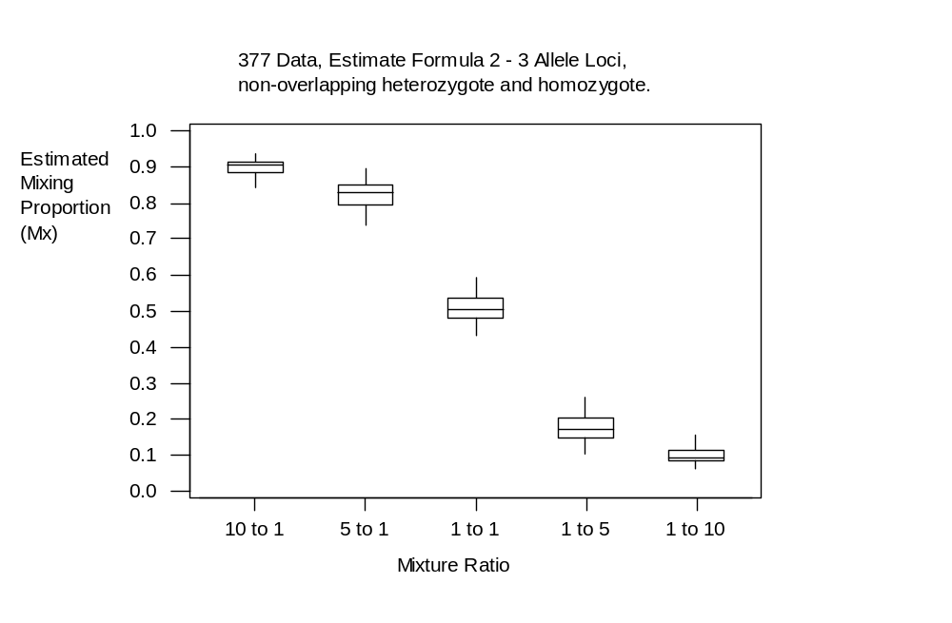

Figure 39: tabulated 377 data indicating mixing ratio, the expected Mx values, the experimental Mx values and the calculated bias (observed – expected).

377 Data - 3 Allele Loci |  |  | (non-overlapping heterozygote & homozygote)
 | (expected) | (observed) | (obs - exptd)
Mixing Ratio | Mx Propn | Experimental Mx | Bias
10 to 1 | 0.909 | 0.90545 | -0.00355
5 to 1 | 0.833 | 0.8297 | -0.0033
1 to 1 | 0.5 | 0.5054 | 0.0054
1 to 5 | 0.167 | 0.1703 | 0.0033
1 to 10 | 0.091 | 0.09455 | 0.00355

Figure 40: tabulated 377 data showing the interquartile range data, indicating the variability within this data set.

377 Data | (non-overlapping heterozygote & homozygote)
 |  |  | IQR (Q3-Q1)
Mixing Ratio | Q3 | Q1 | Variability
10 to 1 | 0.91293 | 0.8852 | 0.02773
5 to 1 | 0.849 | 0.7955 | 0.0535
1 to 1 | 0.5373 | 0.4821 | 0.0552
1 to 5 | 0.2045 | 0.151 | 0.0535
1 to 10 | 0.1148 | 0.08707 | 0.02773

11.2 3100 Data Set

Below: descriptive statistics for the 3100 Mx estimate formula 2, three allelic peak loci, non-over-lapping heterozygote and homozygote data set.

Variable N Mean Median TrMean StDev SE Mean
10 to 1 10 0.8862 0.8898 0.8881 0.0341 0.0108
5 to 1 12 0.8130 0.8155 0.8141 0.0480 0.0139
1 to 1 6 0.5222 0.5189 0.5222 0.0599 0.0245
1 to 5 12 0.1870 0.1845 0.1859 0.0480 0.0139
1 to 10 10 0.1138 0.1102 0.1119 0.0341 0.0108

Variable Minimum Maximum Q1 Q3
10 to 1 0.8274 0.9306 0.8650 0.9167
5 to 1 0.7151 0.9002 0.7814 0.8484
1 to 1 0.4394 0.6162 0.4794 0.5641
1 to 5 0.0998 0.2849 0.1516 0.2186
1 to 10 0.0694 0.1726 0.0833 0.1350

Figure 41: box plot displaying estimated mixing proportion vs mixture ratio, for the 3100 data set.
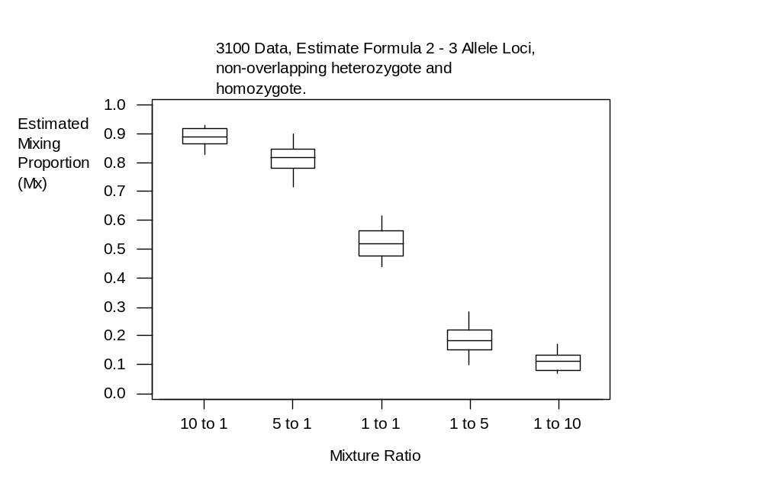

Figure 42: tabulated 3100 data indicating mixing ratio, the expected Mx values, the experimental Mx values and the calculated bias (observed – expected).

3100 Data - 3 Allele Loci |  |  | (non-overlapping het & hom)
 |  | (Observed) | (obs - exptd)
Mixing Ratio | Mx Propn | Experimental Mx | Bias
10 to 1 | 0.909 | 0.8898 | -0.0192
5 to 1 | 0.833 | 0.8155 | -0.0175
1 to 1 | 0.5 | 0.5189 | 0.0189
1 to 5 | 0.167 | 0.1845 | 0.0175
1 to 10 | 0.091 | 0.1102 | 0.0192

Figure 43: tabulated 3100 data showing the interquartile range data, indicating the variability within this data set.

3100 Data |  | (non-overlapping het & hom)
 |  |  | IQR (Q3 - Q1)
Mixing Ratio | Q3 | Q1 | Variability
10 to 1 | 0.9167 | 0.865 | 0.0517
5 to 1 | 0.8484 | 0.7814 | 0.067
1 to 1 | 0.5641 | 0.4794 | 0.0847
1 to 5 | 0.2186 | 0.1516 | 0.067
1 to 10 | 0.135 | 0.0833 | 0.0517

11.3 QLB Data Set

Below: descriptive statistics for the QLB Mx estimate formula 2, three allelic peak loci, non-over-lapping heterozygote and homozygote data set.

Variable N Mean Median TrMean StDev SE Mean
10 to 1 14 0.8610 0.8658 0.8683 0.0611 0.0163
5 to 1 6 0.7644 0.7789 0.7644 0.0423 0.0173
3 to 1 17 0.7021 0.6886 0.7016 0.0620 0.0150
2 to 1 24 0.58161 0.58163 0.58179 0.04022 0.00821
1 to 1 24 0.4405 0.4380 0.4419 0.0523 0.0107
1 to 2 24 0.41161 0.40831 0.41280 0.04469 0.00912
1 to 3 17 0.2917 0.3114 0.2946 0.0722 0.0175
1 to 5 6 0.2356 0.2211 0.2356 0.0423 0.0173
1 to 10 14 0.1301 0.1342 0.1286 0.0407 0.0109

Variable Minimum Maximum Q1 Q3
10 to 1 0.6949 0.9394 0.8577 0.8912
5 to 1 0.7070 0.8127 0.7155 0.7960
3 to 1 0.5968 0.8152 0.6460 0.7610
2 to 1 0.50983 0.64943 0.55534 0.60710
1 to 1 0.3245 0.5248 0.3961 0.4776
1 to 2 0.30680 0.49017 0.38727 0.44093
1 to 3 0.1379 0.4032 0.2348 0.3540
1 to 5 0.1873 0.2930 0.2040 0.2845
1 to 10 0.0606 0.2180 0.1088 0.1423

Figure 44: box plot displaying estimated mixing proportion vs mixture ratio, for the QLB data set.
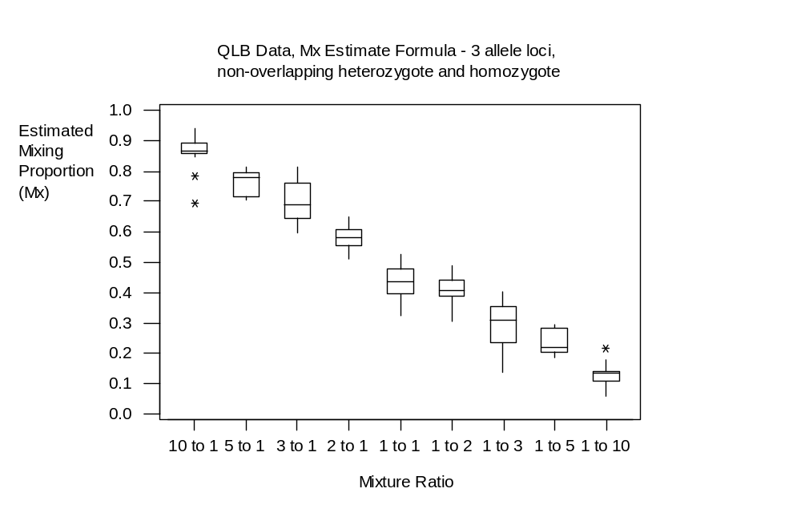
Figure 45: tabulated QLB data indicating mixing ratio, the expected Mx values, the experimental Mx values and the calculated bias (observed – expected).

QLB Data - 3 Allele Loci |  |  | (non-overlapping het & hom)
 | (expected) | (observation) | (obs-exp)
Mixing Ratio | Mx Propn | Experimental Mx | Bias
10 to 1 | 0.909 | 0.8658 | -0.0432
5 to 1 | 0.833 | 0.7789 | -0.0541
3 to 1 | 0.75 | 0.6886 | -0.0614
2 to 1 | 0.667 | 0.58163 | -0.08537
1 to 1 | 0.5 | 0.438 | -0.062
1 to 2 | 0.333 | 0.40831 | 0.07531
1 to 3 | 0.25 | 0.3114 | 0.0614
1 to 5 | 0.167 | 0.2211 | 0.0541
1 to 10 | 0.091 | 0.1342 | 0.0432

Figure 46: tabulated QLB data showing the interquartile range data, indicating the variability within this data set.

QLB Data |  | (non-overlapping het & hom)
 |  |  | IQR (Q3-Q1)
Mixing Ratio | Q3 | Q1 | Variability
10 to 1 | 0.8912 | 0.8577 | 0.0335
5 to 1 | 0.796 | 0.7155 | 0.0805
3 to 1 | 0.761 | 0.646 | 0.115
2 to 1 | 0.6071 | 0.55534 | 0.05176
1 to 1 | 0.4776 | 0.3961 | 0.0815
1 to 2 | 0.44093 | 0.38727 | 0.05366
1 to 3 | 0.354 | 0.2348 | 0.1192
1 to 5 | 0.2845 | 0.204 | 0.0805
1 to 10 | 0.1423 | 0.1088 | 0.0335

12 Appendix C – Mixing Proportion Estimate Formula 3, three allelic peak loci, 2 heterozygotes sharing 1 allele.

12.1 377 Data Set

Below: descriptive statistics for the 377 Mx estimate formula 3, three allelic peak loci, 2 heterozygotes sharing 1 allele, data set

Variable N Mean Median TrMean StDev SE Mean
10 to 1 18 0.9024 0.8891 0.8995 0.0790 0.0186
5 to 1 18 0.8354 0.8284 0.8369 0.0726 0.0171
1 to 1 9 0.4923 0.4933 0.4923 0.0571 0.0190
1 to 5 18 0.1646 0.1716 0.1631 0.0726 0.0171
1 to 10 18 0.0976 0.1109 0.1005 0.0790 0.0186

Variable Minimum Maximum Q1 Q3
10 to 1 0.7975 1.0526 0.8412 0.9562
5 to 1 0.6723 0.9747 0.8152 0.8738
1 to 1 0.4176 0.5874 0.4439 0.5382
1 to 5 0.0253 0.3277 0.1262 0.1848
1 to 10 -0.0526 0.2025 0.0438 0.1588

Figure 47: box plot displaying estimated mixing proportion vs mixture ratio, for the 377 data set.
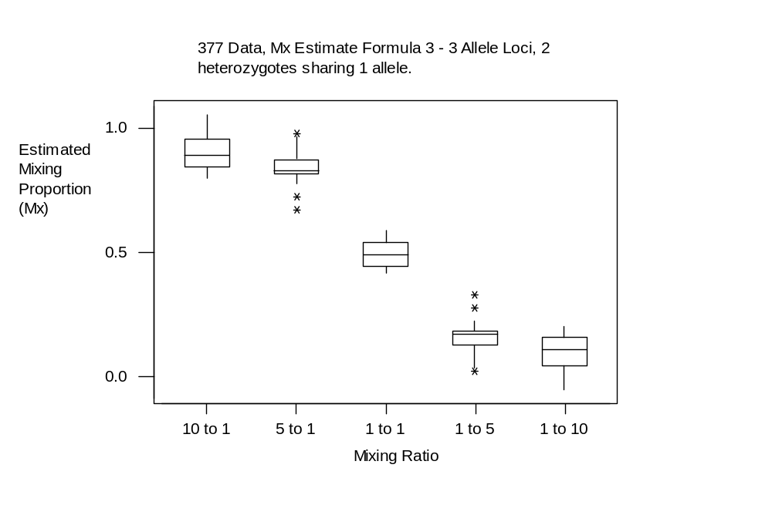

Figure 48: tabulated 377 data indicating mixing ratio, the expected Mx values, the experimental Mx values and the calculated bias (observed – expected).

377 Data |  | (2 hets with 1 allele in common)
 | (expected) | (observed) | (obs - exptd)
Mixing Ratio | Mx Propn | Experimental Mx | Bias
10 to 1 | 0.909 | 0.8891 | -0.0199
5 to 1 | 0.833 | 0.8284 | -0.0046
1 to 1 | 0.5 | 0.4933 | -0.0067
1 to 5 | 0.167 | 0.1716 | 0.0046
1 to 10 | 0.091 | 0.1109 | 0.0199

Figure 49: tabulated 377 data showing the interquartile range data, indicating the variability within this data set.

377 Data |  | (2 hets with 1 allele in common)
 |  |  | IQR (Q3-Q1)
Mixing Ratio | Q3 | Q1 | Variability
10 to 1 | 0.9562 | 0.8412 | 0.115
5 to 1 | 0.8738 | 0.8152 | 0.0586
1 to 1 | 0.5382 | 0.4439 | 0.0943
1 to 5 | 0.1848 | 0.1262 | 0.0586
1 to 10 | 0.1588 | 0.0438 | 0.115

12.2 3100 Data Set

Below: descriptive statistics for the 3100 Mx estimate formula 3, three allelic peak loci, 2 heterozygotes sharing 1 allele, data set

Variable N Mean Median TrMean StDev SE Mean
10 to 1 18 0.8722 0.8631 0.8695 0.0733 0.0173
5 to 1 18 0.8087 0.8077 0.8078 0.0685 0.0161
1 to 1 9 0.5055 0.5051 0.5055 0.0588 0.0196
1 to 5 18 0.1913 0.1923 0.1922 0.0685 0.0161
1 to 10 18 0.1278 0.1369 0.1305 0.0733 0.0173

Variable Minimum Maximum Q1 Q3
10 to 1 0.7716 1.0170 0.8064 0.9172
5 to 1 0.6735 0.9581 0.7770 0.8337
1 to 1 0.4196 0.5898 0.4490 0.5570
1 to 5 0.0419 0.3265 0.1663 0.2230
1 to 10 -0.0170 0.2284 0.0828 0.1936

Figure 50: box plot displaying estimated mixing proportion vs mixture ratio, for the 3100 data set.

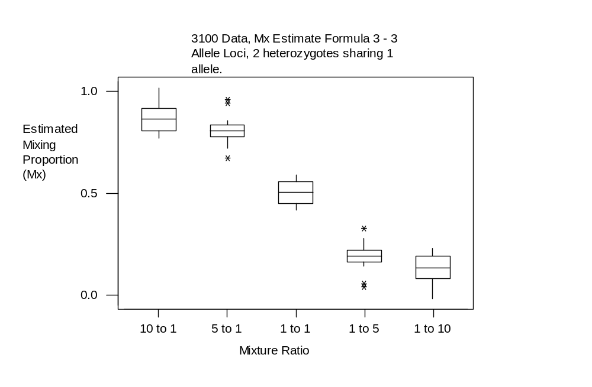

Figure 51: tabulated 3100 data indicating mixing ratio, the expected Mx values, the experimental Mx values and the calculated bias (observed – expected).

3100 Data - 3 Allele Loci |  |  | (2 hets with 1 allele in common)
 |  | (Observed) | (obs - exptd)
Mixing Ratio | Mx Propn | Experimental Mx | Bias
10 to 1 | 0.909 | 0.8631 | -0.0459
5 to 1 | 0.833 | 0.8077 | -0.0253
1 to 1 | 0.5 | 0.5051 | 0.0051
1 to 5 | 0.167 | 0.1923 | 0.0253
1 to 10 | 0.091 | 0.1369 | 0.0459

Figure 52: tabulated 3100 data showing the interquartile range data, indicating the variability within this data set.

3100 Data |  | (2 hets with 1 allele in common)
 |  |  | IQR (Q3 - Q1)
Mixing Ratio | Q3 | Q1 | Variability
10 to 1 | 0.9172 | 0.8064 | 0.1108
5 to 1 | 0.8337 | 0.777 | 0.0567
1 to 1 | 0.557 | 0.449 | 0.108
1 to 5 | 0.223 | 0.1663 | 0.0567
1 to 10 | 0.1936 | 0.0828 | 0.1108

12.3 QLB Data Set

Below: descriptive statistics for the QLB Mx estimate formula 3, three allelic peak loci, 2 heterozygotes sharing 1 allele, data set

Variable N Mean Median TrMean StDev SE Mean
10 to 1 20 0.8970 0.9083 0.8971 0.0675 0.0151
5 to 1 40 0.7590 0.7621 0.7672 0.0878 0.0139
3 to 1 47 0.7032 0.7058 0.7055 0.0983 0.0143
2 to 1 36 0.5534 0.5637 0.5569 0.0898 0.0150
1 to 1 48 0.4172 0.4185 0.4170 0.0776 0.0112
1 to 2 36 0.4466 0.4363 0.4431 0.0898 0.0150
1 to 3 47 0.2869 0.2871 0.2888 0.0961 0.0140
1 to 5 40 0.23057 0.23791 0.23183 0.04923 0.00778
1 to 10 20 0.1030 0.0917 0.1029 0.0675 0.0151

Variable Minimum Maximum Q1 Q3
10 to 1 0.7704 1.0214 0.8247 0.9502
5 to 1 0.3084 0.9144 0.7409 0.7983
3 to 1 0.3874 0.9050 0.6517 0.7432
2 to 1 0.2675 0.7411 0.5007 0.6090
1 to 1 0.2558 0.5796 0.3639 0.4757
1 to 2 0.2589 0.7325 0.3910 0.4993
1 to 3 0.0411 0.4775 0.2566 0.3483
1 to 5 0.08562 0.34794 0.20170 0.25911
1 to 10 -0.0214 0.2296 0.0498 0.1753

Figure 53: box plot displaying estimated mixing proportion vs mixture ratio, for the QLB data set.
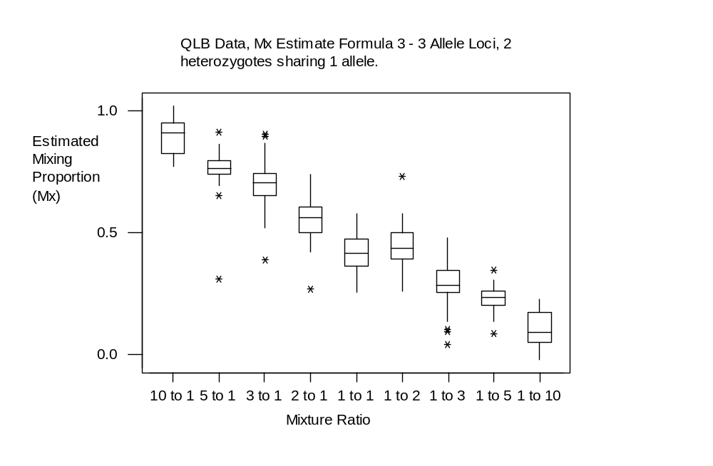
Figure 54: tabulated QLB data indicating mixing ratio, the expected Mx values, the experimental Mx values and the calculated bias (observed – expected).

QLB Data - 3 Allele Loci |  |  | (2 hets with 1 allele in common)
 | (expected) | (observation) | (obs-exp)
Mixing Ratio | Mx Propn | Experimental Mx | Bias
10 to 1 | 0.909 | 0.9083 | -0.0007
5 to 1 | 0.833 | 0.7621 | -0.0709
3 to 1 | 0.75 | 0.7058 | -0.0442
2 to 1 | 0.667 | 0.5637 | -0.1033
1 to 1 | 0.5 | 0.4185 | -0.0815
1 to 2 | 0.333 | 0.4363 | 0.1033
1 to 3 | 0.25 | 0.2871 | 0.0371
1 to 5 | 0.167 | 0.23791 | 0.07091
1 to 10 | 0.091 | 0.0917 | 0.0007

Figure 55: tabulated QLB data showing the interquartile range data, indicating the variability within this data set.

QLB Data |  | (2 hets with 1 allele in common)
 |  |  | IQR (Q3-Q1)
Mixing Ratio | Q3 | Q1 | Variability
10 to 1 | 0.9502 | 0.8247 | 0.1255
5 to 1 | 0.7983 | 0.7409 | 0.0574
3 to 1 | 0.7432 | 0.6517 | 0.0915
2 to 1 | 0.609 | 0.5007 | 0.1083
1 to 1 | 0.4757 | 0.3639 | 0.1118
1 to 2 | 0.4993 | 0.391 | 0.1083
1 to 3 | 0.3483 | 0.2566 | 0.0917
1 to 5 | 0.25911 | 0.2017 | 0.05741
1 to 10 | 0.1753 | 0.0498 | 0.1255

13 Appendix D – Mixing Proportion Estimate Formula 4, two allelic peak loci, 2 non-overlapping homozygotes.

13.1 QLB Data Set - only

Below: descriptive statistics for the QLB Mx estimate formula 4, two allelic peak loci, 2 non-overlapping homozygotes, data set.

Variable N Mean Median TrMean StDev SE Mean
5 to 1 12 0.7574 0.7454 0.7545 0.0349 0.0101
3 to 1 6 0.6942 0.6980 0.6942 0.0683 0.0279
1 to 1 6 0.45625 0.44914 0.45625 0.02153 0.00879
1 to 3 6 0.3058 0.3020 0.3058 0.0683 0.0279
1 to 5 12 0.2426 0.2546 0.2455 0.0349 0.0101

Variable Minimum Maximum Q1 Q3
5 to 1 0.7171 0.8264 0.7285 0.7867
3 to 1 0.5839 0.7676 0.6392 0.7620
1 to 1 0.43576 0.48594 0.43716 0.48141
1 to 3 0.2324 0.4161 0.2380 0.3608
1 to 5 0.1736 0.2829 0.2133 0.2715

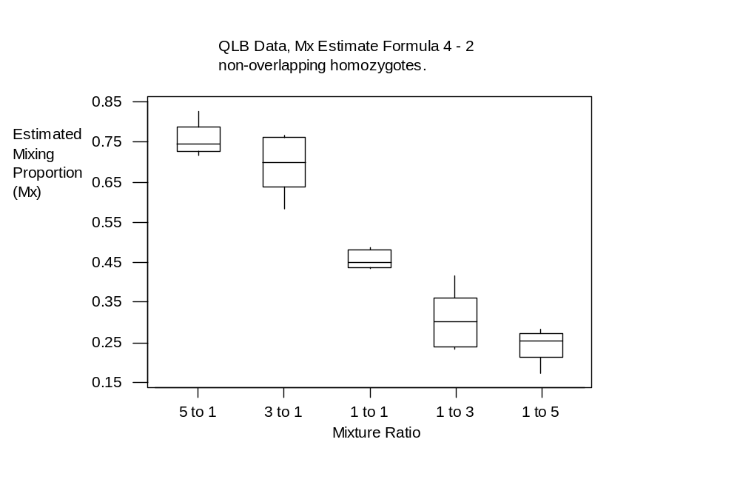Figure 56: box plot displaying estimated mixing proportion vs mixture ratio, for the QLB data set.

Figure 57: tabulated QLB data indicating mixing ratio, the expected Mx values, the experimental Mx values and the calculated bias (observed – expected).

QLB Data - 2 Allele Loci |  |  | (2 non-overlapping homs)
 | (expected) | (observation) | (obs-exp)
Mixing Ratio | Mx Propn | Experimental Mx | Bias
10 to 1 | 0.909 | no data
5 to 1 | 0.833 | 0.7454 | -0.0876
3 to 1 | 0.75 | 0.698 | -0.052
2 to 1 | 0.667 | no data
1 to 1 | 0.5 | 0.44914 | -0.05086
1 to 2 | 0.333 | no data
1 to 3 | 0.25 | 0.302 | 0.052
1 to 5 | 0.167 | 0.2546 | 0.0876
1 to 10 | 0.091 | no data

Figure 58: tabulated QLB data showing the interquartile range data, indicating the variability within this data set.

QLB Data |  | (2 non-overlapping homs)
 |  |  | IQR (Q3-Q1)
Mixing Ratio | Q3 | Q1 | Variability
10 to 1 | no data | no data
5 to 1 | 0.7867 | 0.7285 | 0.0582
3 to 1 | 0.762 | 0.6392 | 0.1228
2 to 1 | no data | no data
1 to 1 | 0.48141 | 0.43716 | 0.04425
1 to 2 | no data | no data
1 to 3 | 0.3608 | 0.238 | 0.1228
1 to 5 | 0.2715 | 0.2133 | 0.0582
1 to 10 | no data | no data

14 Appendix E – Mixing Proportion Estimate Formula 5, two allelic peak loci, 1 heterozygote and 1 homozygote sharing 1 allele.

14.1 377 Data Set

Below: descriptive statistics for the 377 Mx estimate formula 5, two allelic peak loci, 1 heterozygote and 1 homozygote sharing 1 allele.

Variable N Mean Median TrMean StDev SE Mean
10 to 1 6 0.9558 0.9719 0.9558 0.0455 0.0186
5 to 1 6 0.8056 0.7930 0.8056 0.0499 0.0204
1 to 1 3 0.4965 0.5071 0.4965 0.0603 0.0348
1 to 5 6 0.1944 0.2070 0.1944 0.0499 0.0204
1 to 10 6 0.0442 0.0281 0.0442 0.0455 0.0186

Variable Minimum Maximum Q1 Q3
10 to 1 0.8818 1.0065 0.9124 0.9866
5 to 1 0.7411 0.8670 0.7674 0.8642
1 to 1 0.4315 0.5508 0.4315 0.5508
1 to 5 0.1330 0.2589 0.1358 0.2326
1 to 10 -0.0065 0.1182 0.0134 0.0876

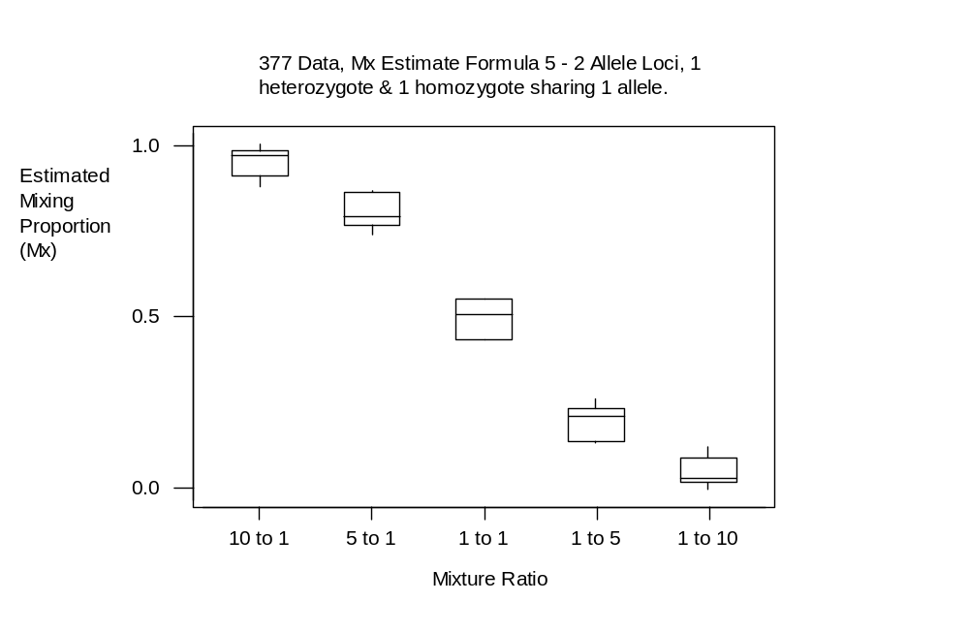Figure 59: box plot displaying estimated mixing proportion vs mixture ratio, for the 377 data set.

Figure 60: tabulated 377 data indicating mixing ratio, the expected Mx values, the experimental Mx values and the calculated bias (observed – expected).

377 Data | (1 heterozygote & 1 homozygote sharing1 allele)
 | (expected) | (observed) | (obs - exptd)
Mixing Ratio | Mx Propn | Experimental Mx | Bias
10 to 1 | 0.909 | 0.9719 | 0.0629
5 to 1 | 0.833 | 0.793 | -0.04
1 to 1 | 0.5 | 0.5071 | 0.0071
1 to 5 | 0.167 | 0.207 | 0.04
1 to 10 | 0.091 | 0.0281 | -0.0629

Figure 61: tabulated 377 data showing the interquartile range data, indicating the variability within this data set.

377 Data | (1 heterozygote & 1 homozygote sharing1 allele)
 |  |  | IQR (Q3-Q1)
Mixing Ratio | Q3 | Q1 | Variability
10 to 1 | 0.9866 | 0.9124 | 0.0742
5 to 1 | 0.8642 | 0.7674 | 0.0968
1 to 1 | 0.5508 | 0.4315 | 0.1193
1 to 5 | 0.2326 | 0.1358 | 0.0968
1 to 10 | 0.0876 | 0.0134 | 0.0742

14.2 3100 Data Set

Below: descriptive statistics for the 3100 Mx estimate formula 5, two allelic peak loci, 1 heterozygote and 1 homozygote sharing 1 allele.

Variable N Mean Median TrMean StDev SE Mean
10 to 1 5 0.9384 0.9238 0.9384 0.0437 0.0196
5 to 1 6 0.7930 0.7738 0.7930 0.0513 0.0209
1 to 1 3 0.5288 0.5424 0.5288 0.0371 0.0214
1 to 5 6 0.2070 0.2262 0.2070 0.0513 0.0209
1 to 10 5 0.0616 0.0762 0.0616 0.0437 0.0196

Variable Minimum Maximum Q1 Q3
10 to 1 0.8871 0.9967 0.9015 0.9826
5 to 1 0.7487 0.8595 0.7498 0.8537
1 to 1 0.4868 0.5572 0.4868 0.5572
1 to 5 0.1405 0.2513 0.1463 0.2502
1 to 10 0.0033 0.1129 0.0174 0.0985

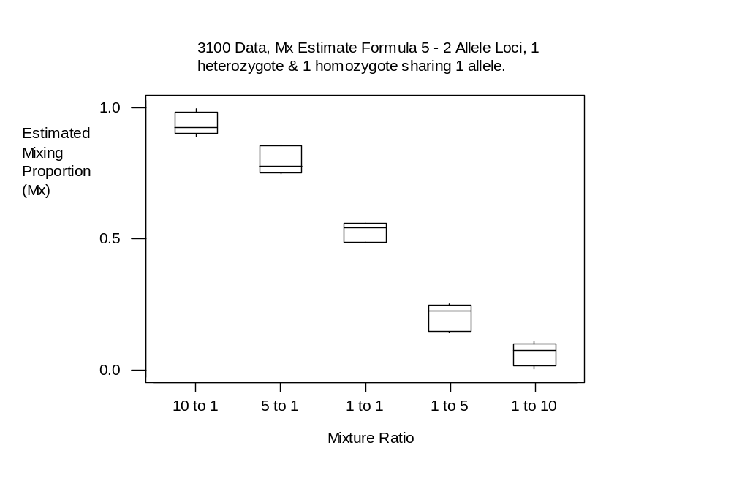Figure 62: box plot displaying estimated mixing proportion vs mixture ratio, for the 3100 data set.

Figure 63: tabulated 3100 data indicating mixing ratio, the expected Mx values, the experimental Mx values and the calculated bias (observed – expected).

3100 Data |  |  | (1 het & 1 hom sharing 1 allele)
 |  | (Observed) | (obs - exptd)
Mixing Ratio | Mx Propn | Experimental Mx | Bias
10 to 1 | 0.909 | 0.9238 | 0.0148
5 to 1 | 0.833 | 0.7738 | -0.0592
1 to 1 | 0.5 | 0.5424 | 0.0424
1 to 5 | 0.167 | 0.2262 | 0.0592
1 to 10 | 0.091 | 0.0762 | -0.0148

Figure 64: tabulated 3100 data showing the interquartile range data, indicating the variability within this data set.

3100 Data |  | (1 het & 1 hom sharing 1 allele)
 |  |  | IQR (Q3 - Q1)
Mixing Ratio | Q3 | Q1 | Variability
10 to 1 | 0.9826 | 0.9015 | 0.0811
5 to 1 | 0.8537 | 0.7498 | 0.1039
1 to 1 | 0.5572 | 0.4868 | 0.0704
1 to 5 | 0.2502 | 0.1463 | 0.1039
1 to 10 | 0.0985 | 0.0174 | 0.0811

14.3 QLB Data Set

Below: descriptive statistics for the QLB Mx estimate formula 5, two allelic peak loci, 1 heterozygote and 1 homozygote sharing 1 allele.

Variable N Mean Median TrMean StDev SE Mean
10 to 1 40 0.8792 0.8935 0.8802 0.1027 0.0162
5 to 1 12 0.7610 0.7816 0.7646 0.0901 0.0260
3 to 1 30 0.7176 0.7153 0.7142 0.0883 0.0161
2 to 1 6 0.4958 0.4896 0.4958 0.0923 0.0377
1 to 1 12 0.4587 0.4892 0.4577 0.1150 0.0332
1 to 2 18 0.3685 0.3485 0.3630 0.1276 0.0301
1 to 3 18 0.2702 0.2847 0.2715 0.0941 0.0222
1 to 5 12 0.2390 0.2184 0.2354 0.0901 0.0260
1 to 10 40 0.1163 0.0906 0.1148 0.1043 0.0165

Variable Minimum Maximum Q1 Q3
10 to 1 0.6147 1.0831 0.8085 0.9287
5 to 1 0.5982 0.8880 0.6694 0.8323
3 to 1 0.5774 0.9034 0.6489 0.7819
2 to 1 0.3831 0.6605 0.4299 0.5450
1 to 1 0.2859 0.6414 0.3391 0.5277
1 to 2 0.2091 0.6169 0.2341 0.4975
1 to 3 0.0966 0.4226 0.2123 0.3479
1 to 5 0.1120 0.4018 0.1677 0.3306
1 to 10 -0.0831 0.3853 0.0680 0.1915

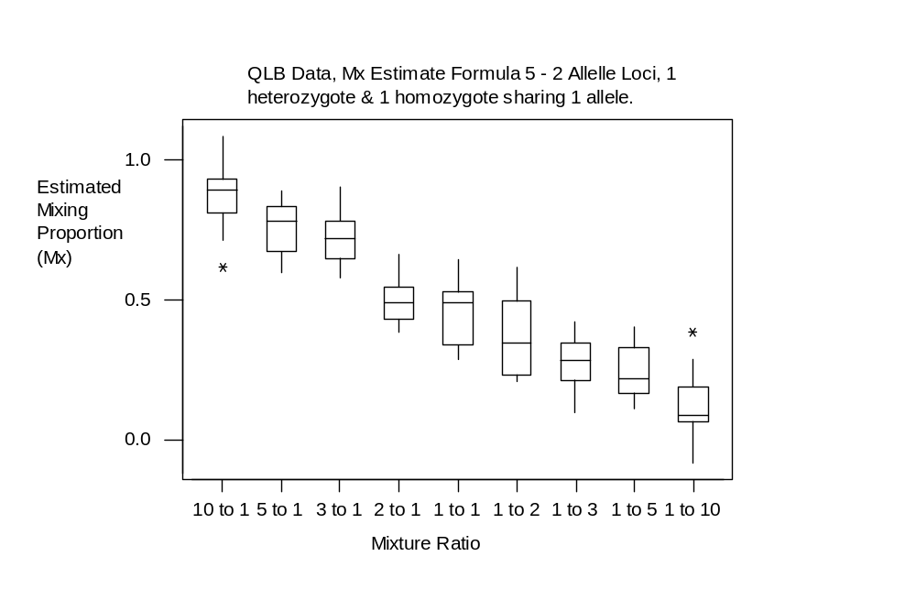Figure 65: box plot displaying estimated mixing proportion vs mixture ratio, for the QLB data set.
Figure 66: tabulated QLB data indicating mixing ratio, the expected Mx values, the experimental Mx values and the calculated bias (observed – expected).

QLB Data | (1 het & 1 hom with 1 allele in common)
 | (expected) | (observation) | (obs-exp)
Mixing Ratio | Mx Propn | Experimental Mx | Bias
10 to 1 | 0.909 | 0.8935 | -0.0155
5 to 1 | 0.833 | 0.7816 | -0.0514
3 to 1 | 0.75 | 0.7153 | -0.0347
2 to 1 | 0.667 | 0.4896 | -0.1774
1 to 1 | 0.5 | 0.4892 | -0.0108
1 to 2 | 0.333 | 0.3485 | 0.0155
1 to 3 | 0.25 | 0.2847 | 0.0347
1 to 5 | 0.167 | 0.2184 | 0.0514
1 to 10 | 0.091 | 0.0906 | -0.0004

Figure 67: tabulated QLB data showing the interquartile range data, indicating the variability within this data set.

QLB Data | (1 het & 1 hom with 1 allele in common)
 |  |  | IQR (Q3-Q1)
Mixing Ratio | Q3 | Q1 | Variability
10 to 1 | 0.9287 | 0.8085 | 0.1202
5 to 1 | 0.8323 | 0.6694 | 0.1629
3 to 1 | 0.7819 | 0.6489 | 0.133
2 to 1 | 0.545 | 0.4299 | 0.1151
1 to 1 | 0.5277 | 0.3391 | 0.1886
1 to 2 | 0.4975 | 0.2341 | 0.2634
1 to 3 | 0.3479 | 0.2123 | 0.1356
1 to 5 | 0.3306 | 0.1677 | 0.1629
1 to 10 | 0.1915 | 0.068 | 0.1235

15 Appendix F – Spread In Mixing Proportion Estimates – Full, combined data sets.

15.1 Combined 377 Data Set

Below: descriptive statistics for the full and combined 377 data set.

Variable N Mean Median TrMean StDev SE Mean
10 : 1 53 0.91040 0.91145 0.90909 0.05416 0.00744
5 : 1 54 0.83059 0.83026 0.83054 0.05294 0.00720
1 : 1 27 0.50197 0.49903 0.50164 0.04987 0.00960
1 : 5 54 0.16941 0.16974 0.16946 0.05294 0.00720
1 : 10 53 0.08960 0.08855 0.09091 0.05416 0.00744

Variable Minimum Maximum Q1 Q3
10 : 1 0.79747 1.05262 0.88214 0.93377
5 : 1 0.67225 0.97469 0.80498 0.86607
1 : 1 0.41759 0.59479 0.46231 0.54430
1 : 5 0.02531 0.32775 0.13393 0.19502
1 : 10 -0.05262 0.20253 0.06623 0.11786

Figure 68: tabulated combined 377 data indicating mixing ratio, the expected Mx values, the experimental Mx values and the calculated bias (observed – expected).

377 Full Data
 | (expected) | (observed) | (obs - exptd)
Mixing Ratio | Mx Propn | Experimental Mx | Bias
10 to 1 | 0.909 | 0.91145 | 0.00245
5 to 1 | 0.833 | 0.83026 | -0.00274
1 to 1 | 0.5 | 0.49903 | -0.00097
1 to 5 | 0.167 | 0.16974 | 0.00274
1 to 10 | 0.091 | 0.08855 | -0.00245

Figure 69: tabulated combined 377 data showing the interquartile range data, indicating the variability within this data set.

377 Full Data
 |  |  | IQR (Q3-Q1)
Mixing Ratio | Q3 | Q1 | Variability
10 to 1 | 0.93377 | 0.88214 | 0.05163
5 to 1 | 0.86607 | 0.80498 | 0.06109
1 to 1 | 0.5443 | 0.46231 | 0.08199
1 to 5 | 0.19502 | 0.13393 | 0.06109
1 to 10 | 0.11786 | 0.06623 | 0.05163

15.2 Combined 3100 Data Set

Below: descriptive statistics for the full and combined 3100 data set.

Variable N Mean Median TrMean StDev SE Mean
10 : 1 50 0.88923 0.88932 0.88835 0.05464 0.00773
5 : 1 54 0.81170 0.80986 0.81086 0.05220 0.00710
1 : 1 27 0.51544 0.51145 0.51524 0.04850 0.00933
1 : 5 54 0.18830 0.19014 0.18914 0.05220 0.00710
1 : 10 50 0.11077 0.11068 0.11165 0.05464 0.00773

Variable Minimum Maximum Q1 Q3
10 : 1 0.77164 1.01702 0.85671 0.91855
5 : 1 0.67349 0.95814 0.78263 0.84799
1 : 1 0.41963 0.61624 0.48678 0.54667
1 : 5 0.04186 0.32651 0.15201 0.21737
1 : 10 -0.01702 0.22836 0.08145 0.14329

Figure 70: tabulated combined 3100 data indicating mixing ratio, the expected Mx values, the experimental Mx values and the calculated bias (observed – expected).

3100 Full Data
 | (expected) | (observed) | (obs - exptd)
Mixing Ratio | Mx Propn | Experimental Mx | Bias
10 to 1 | 0.909 | 0.88932 | -0.21819
5 to 1 | 0.833 | 0.80986 | -0.15790
1 to 1 | 0.5 | 0.51145 | 0.04581
1 to 5 | 0.167 | 0.19014 | 0.15790
1 to 10 | 0.091 | 0.11068 | 0.21819

Figure 70: tabulated combined 3100 data showing the interquartile range data, indicating the variability within this data set.

3100 Full Data
 |  |  | IQR (Q3-Q1)
Mixing Ratio | Q3 | Q1 | Variability
10 to 1 | 0.91855 | 0.85671 | 0.06184
5 to 1 | 0.84799 | 0.78263 | 0.06536
1 to 1 | 0.54667 | 0.48678 | 0.05989
1 to 5 | 0.21737 | 0.15201 | 0.06536
1 to 10 | 0.14329 | 0.08145 | 0.06184

15.3 Combined QLB Data Set

Below: descriptive statistics for the full and combined QLB data set.

Variable N Mean Median TrMean StDev SE Mean
10 to 1 87 0.87934 0.88088 0.88006 0.08341 0.00894
5 to 1 99 0.76624 0.77216 0.77062 0.07234 0.00727
3 to 1 118 0.71105 0.71109 0.71092 0.08346 0.00768
2 to 1 102 0.56596 0.56745 0.56640 0.07757 0.00768
1 to 1 114 0.42933 0.42897 0.42920 0.07202 0.00675
1 to 2 114 0.41858 0.42216 0.41930 0.08813 0.00825
1 to 3 105 0.28376 0.28714 0.28569 0.08279 0.00808
1 to 5 101 0.22945 0.22784 0.22868 0.05448 0.00542
1 to 10 87 0.11715 0.10827 0.11686 0.08217 0.00881

Variable Minimum Maximum Q1 Q3
10 to 1 0.61473 1.08314 0.82426 0.92704
5 to 1 0.30843 0.91438 0.73813 0.80750
3 to 1 0.38739 0.90502 0.65709 0.76395
2 to 1 0.26747 0.76630 0.52321 0.60850
1 to 1 0.25581 0.64139 0.38393 0.47956
1 to 2 0.20910 0.73253 0.36163 0.47152
1 to 3 0.04110 0.47750 0.23693 0.33979
1 to 5 0.08562 0.40178 0.19384 0.26314
1 to 10 -0.08314 0.38527 0.07292 0.17574

Figure 71: tabulated combined QLB data indicating mixing ratio, the expected Mx values, the experimental Mx values and the calculated bias (observed – expected).

QLB Full Data
 | (expected) | (observation) | (obs-exp)
Mixing Ratio | Mx Propn | Experimental Mx | Bias
10 to 1 | 0.909 | 0.88088 | -0.02812
5 to 1 | 0.833 | 0.77216 | -0.06084
3 to 1 | 0.75 | 0.71109 | -0.03891
2 to 1 | 0.667 | 0.56745 | -0.09955
1 to 1 | 0.5 | 0.42897 | -0.07103
1 to 2 | 0.333 | 0.42216 | 0.08916
1 to 3 | 0.25 | 0.28714 | 0.03714
1 to 5 | 0.167 | 0.22784 | 0.06084
1 to 10 | 0.091 | 0.10827 | 0.01727

Figure 72: tabulated combined 3100 data showing the interquartile range data, indicating the variability within this data set.

QLB Full Data
 |  |  | IQR (Q3-Q1)
Mixing Ratio | Q3 | Q1 | Variability
10 to 1 | 0.92704 | 0.82426 | 0.10278
5 to 1 | 0.8075 | 0.73813 | 0.06937
3 to 1 | 0.76395 | 0.65709 | 0.10686
2 to 1 | 0.6085 | 0.52321 | 0.08529
1 to 1 | 0.47956 | 0.38393 | 0.09563
1 to 2 | 0.47152 | 0.36163 | 0.10989
1 to 3 | 0.33979 | 0.23693 | 0.10286
1 to 5 | 0.26314 | 0.19384 | 0.0693
1 to 10 | 0.17574 | 0.07292 | 0.10282

16 Appendix G – Individual Mx Estimate Formulae Effects.

16.1 Combined 377 Data Set

Below: descriptive statistics for the full and combined 377 data set, separated by Mx estimate formula (denoted in the data as ‘variable’).

Variable N Mean Median TrMean StDev SE Mean
1 80 0.00136 -0.00082 0.00094 0.03363 0.00376
2 52 0.00044 0.00000 0.00013 0.03616 0.00501
3 81 -0.00011 0.00000 -0.00012 0.07295 0.00811
5 27 -0.00118 -0.00003 -0.00127 0.04731 0.00911

Variable Minimum Maximum Q1 Q3
1 -0.07986 0.09422 -0.01874 0.02069
2 -0.09202 0.09202 -0.01697 0.01697
3 -0.16352 0.16352 -0.03978 0.03978
5 -0.09009 0.09009 -0.03463 0.03463

16.2 Combined 3100 Data Set

Below: descriptive statistics for the full and combined 3100 data set, separated by Mx estimate formula (denoted in the data as ‘variable’).

Variable N Mean Median TrMean StDev SE Mean
1 79 0.00058 0.00000 0.00059 0.03530 0.00397
2 51 -0.00178 -0.00178 -0.00173 0.04517 0.00633
3 81 0.00004 -0.00004 0.00005 0.06826 0.00758
5 25 -0.00163 0.00001 -0.00178 0.04626 0.00925

Variable Minimum Maximum Q1 Q3
1 -0.08762 0.08762 -0.02163 0.02163
2 -0.11020 0.10041 -0.03090 0.02777
3 -0.15392 0.15392 -0.03433 0.03484
5 -0.08572 0.08572 -0.03089 0.02439

16.3 Combined QLB Data Set

Below: descriptive statistics for the full and combined QLB data set, separated by Mx estimate formula (denoted in the data as ‘variable’).

Variable N Mean Median TrMean StDev SE Mean
1 213 -0.01911 -0.00106 -0.00356 0.13501 0.00925
2 151 0.00110 0.00038 0.00284 0.05166 0.00420
3 338 -0.01110 -0.00089 -0.00215 0.11865 0.00645
4 42 0.00102 0.00000 0.00112 0.04406 0.00680
5 185 0.00577 0.00073 0.00554 0.10087 0.00742

Variable Minimum Maximum Q1 Q3
1 -0.79300 0.20290 -0.04104 0.03658
2 -0.17352 0.12660 -0.02513 0.03455
3 -0.90830 0.29623 -0.04452 0.04243
4 -0.11411 0.11411 -0.02199 0.02694
5 -0.27877 0.29467 -0.06358 0.06703

17 Appendix H – Individual Locus Effects.

17.1 Combined 377 Data Set

Below: descriptive statistics for the full and combined 377 data set, separated by locus name.

Variable N Mean Median TrMean StDev SE Mean
D16 27 -0.00048 -0.00161 -0.00052 0.03120 0.00600
D2 27 0.00109 0.00297 0.00118 0.02961 0.00570
VWA 25 -0.00334 -0.00385 -0.00363 0.04220 0.00844
AMELO 27 -0.00118 -0.00003 -0.00127 0.04731 0.00911
D18 27 0.0012 0.0057 0.0013 0.0981 0.0189
D21 27 -0.0013 -0.0011 -0.0014 0.0641 0.0123
D8 27 0.00394 0.00388 0.00329 0.02991 0.00576
D19 26 0.00353 0.00131 0.00306 0.04051 0.00794
THO1 27 -0.00017 0.00000 -0.00018 0.05127 0.00987

Variable Minimum Maximum Q1 Q3
D16 -0.07986 0.07986 -0.01579 0.01579
D2 -0.05367 0.05367 -0.02123 0.02123
VWA -0.09202 0.09202 -0.02734 0.02107
AMELO -0.09009 0.09009 -0.03463 0.03463
D18 -0.1561 0.1561 -0.0764 0.0916
D21 -0.1290 0.1290 -0.0511 0.0511
D8 -0.06523 0.08939 -0.01158 0.01633
D19 -0.07576 0.09422 -0.02205 0.03139
THO1 -0.16352 0.16352 -0.02378 0.01920

17.2 Combined 3100 Data Set

Below: descriptive statistics for the full and combined 3100 data set, separated by locus name.

Variable N Mean Median TrMean StDev SE Mean
D16 25 0.00084 0.00029 0.00091 0.03182 0.00636
D2 27 0.00044 -0.00000 0.00048 0.03552 0.00684
VWA 25 -0.00501 -0.00180 -0.00545 0.04429 0.00886
AMELO 25 -0.00163 0.00001 -0.00178 0.04626 0.00925
D18 27 0.0002 -0.0029 0.0002 0.0976 0.0188
D21 27 -0.00012 0.00486 -0.00013 0.04722 0.00909
D8 25 0.00580 0.01304 0.00575 0.04158 0.00832
D19 27 0.00047 0.00005 0.00051 0.03925 0.00755
THO1 27 0.00004 -0.00004 0.00004 0.05088 0.00979

Variable Minimum Maximum Q1 Q3
D16 -0.05875 0.05875 -0.02002 0.02002
D2 -0.07415 0.07415 -0.02163 0.02163
VWA -0.10041 0.10041 -0.02966 0.01726
AMELO -0.08572 0.08572 -0.03089 0.02439
D18 -0.1508 0.1508 -0.0780 0.0847
D21 -0.09290 0.09290 -0.02984 0.02984
D8 -0.08469 0.09734 -0.02823 0.03158
D19 -0.08762 0.08762 -0.02527 0.02527
THO1 -0.15392 0.15392 -0.02611 0.02611

17.3 Combined QLB Data Set

Below: descriptive statistics for the full and combined QLB data set, separated by locus name.

Variable N Mean Median TrMean StDev SE Mean
D16 92 -0.0026 -0.0046 -0.0009 0.0985 0.0103
D2 78 0.00094 0.00055 0.00115 0.06380 0.00722
D3 108 -0.00027 0.00100 0.00025 0.05796 0.00558
VWA 93 -0.00047 0.00003 -0.00036 0.06282 0.00651
AMELO 54 -0.0059 0.0000 -0.0059 0.0891 0.0121
D18 85 0.0239 -0.0000 0.0065 0.1610 0.0175
D21 91 0.00007 -0.00078 0.00001 0.08846 0.00927
D8 69 -0.0380 0.0037 -0.0099 0.1918 0.0231
D19 92 0.01312 0.00394 0.01150 0.08000 0.00834
FGA 92 -0.0383 -0.0060 -0.0103 0.1699 0.0177
THO 77 -0.0168 0.0000 0.0001 0.1371 0.0156

Variable Minimum Maximum Q1 Q3
D16 -0.3184 0.2962 -0.0545 0.0545
D2 -0.18225 0.18225 -0.03345 0.04180
D3 -0.17094 0.14257 -0.02553 0.03243
VWA -0.14354 0.15106 -0.04181 0.04389
AMELO -0.2033 0.1896 -0.0666 0.0598
D18 -0.2788 0.9064 -0.0515 0.0552
D21 -0.20290 0.20290 -0.05409 0.06119
D8 -0.9083 0.1992 -0.0365 0.0345
D19 -0.18805 0.26837 -0.02436 0.03883
FGA -0.7930 0.1592 -0.0439 0.0351

18 Appendix I – DNA Concentration Effects.

18.1 Combined QLB Data Set

Below: descriptive statistics for the full and combined QLB data set, examining DNA concentration (denoted in the data as ‘variable’).

Variable N Mean Median TrMean StDev SE Mean
0.5 433 -0.01827 -0.00194 -0.00483 0.14706 0.00707
1.0 118 0.01344 0.00203 0.00662 0.10177 0.00937
1.5 213 0.00494 -0.00038 0.00125 0.08630 0.00591
2.0 167 0.00308 0.00036 0.00231 0.04761 0.00368

Variable Minimum Maximum Q1 Q3
0.5 -0.90830 0.29623 -0.06799 0.05751
1.0 -0.18330 0.90636 -0.02351 0.04355
1.5 -0.19244 0.88006 -0.02819 0.03225
2.0 -0.11315 0.20599 -0.02513 0.02964

‘Pendulum’ is a software program; designed to aid the analysis and interpretation of two-person DNA mixed STR profiles. The program uses peak area information to determine probable mixing proportion and major/minor genotypes. It is based on the theory used in Gill et al, 1998 [4].
Box and whisker plots, also called boxplots, are used for displaying distributional characteristics of data. The boxes span the central half of the data and approximately 99.5% observations fall inside the whiskers. Extreme values (outliers) are indicated by asterisks*.
The ‘mirroring’ effect describes the effects caused by the reversal of data. The data were reversed to remove the effect of preferentially choosing one contributor (I.E. 10 to 1 ratio data is reversed and re-analysed as 1 to 10 data, therefore focusing on each contributor). Any anomalies however, will be present in both data sets.
Please note that the Interquartile Range for each graph, throughout this report, has been determined by the data itself and the software package (Microsoft Excel). The scales will vary depending upon the data itself.
Please note, no estimate mixing proportion could be calculated for the Amelogenin locus in this profile, as both contributors shared the same alleles at this locus.
Please note, no estimate mixing proportion could be calculated for the Amelogenin and D8 loci in this profile, as both contributors shared the same alleles at each locus.

